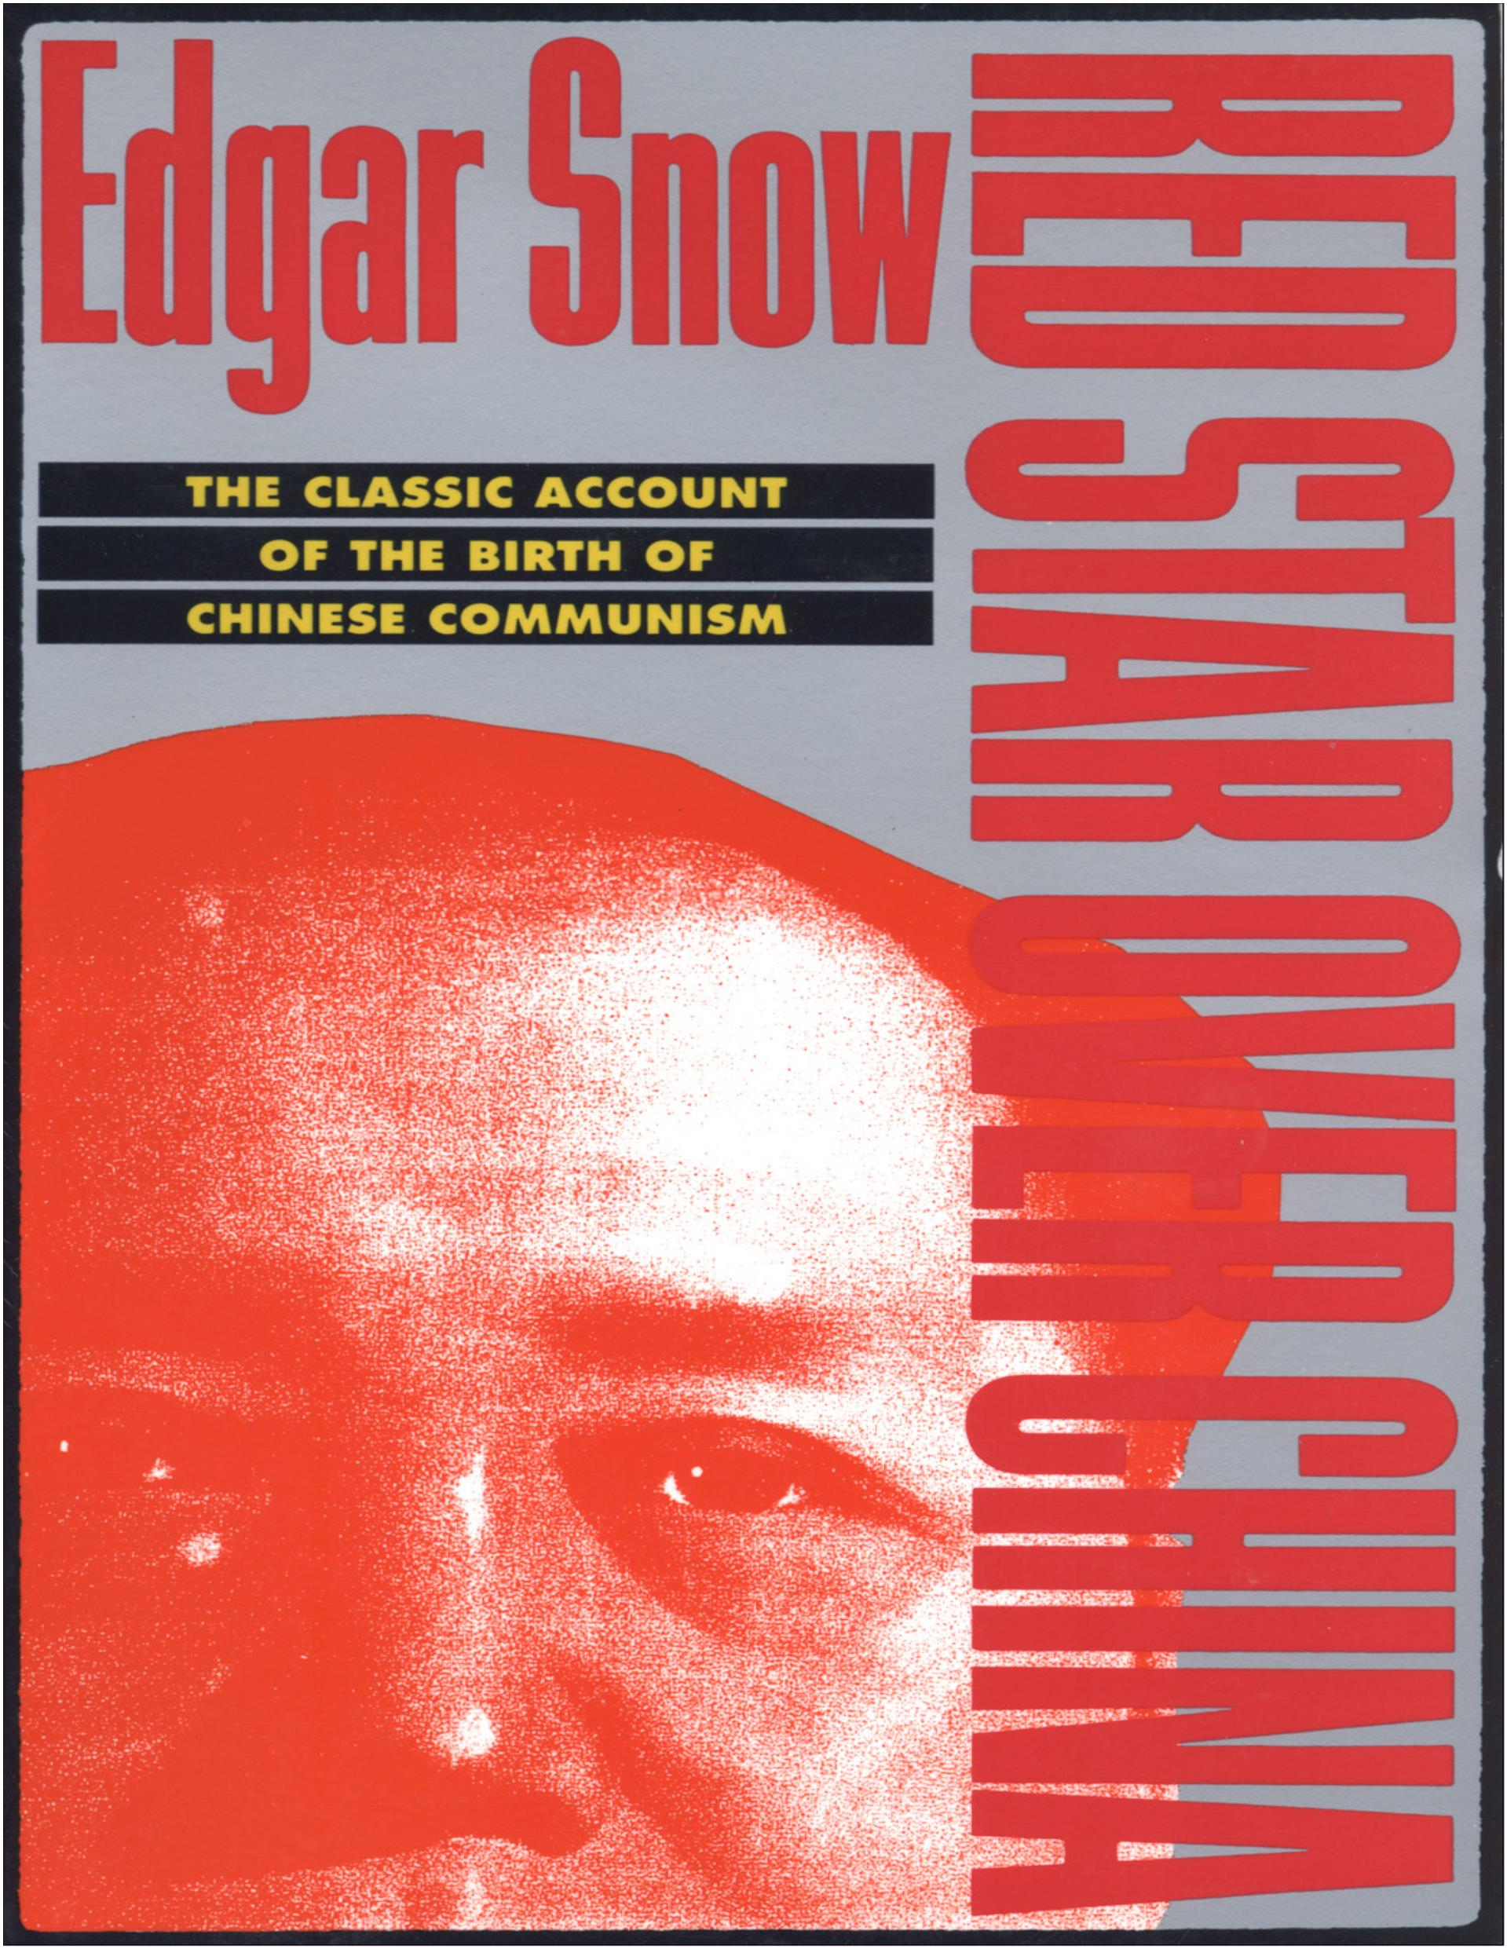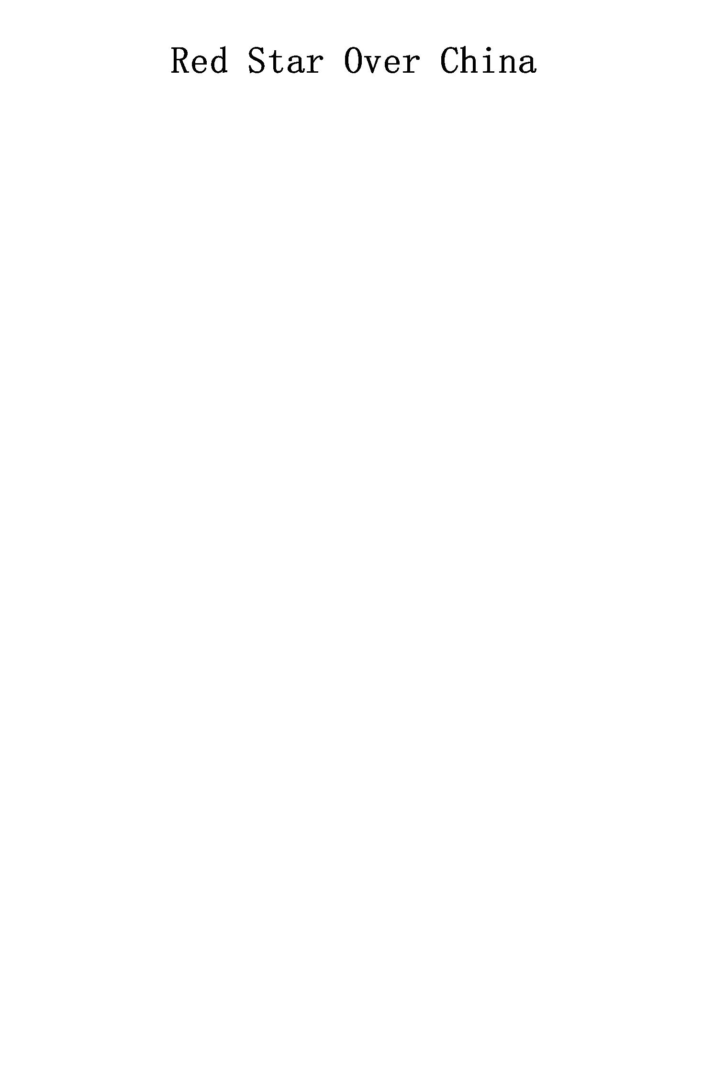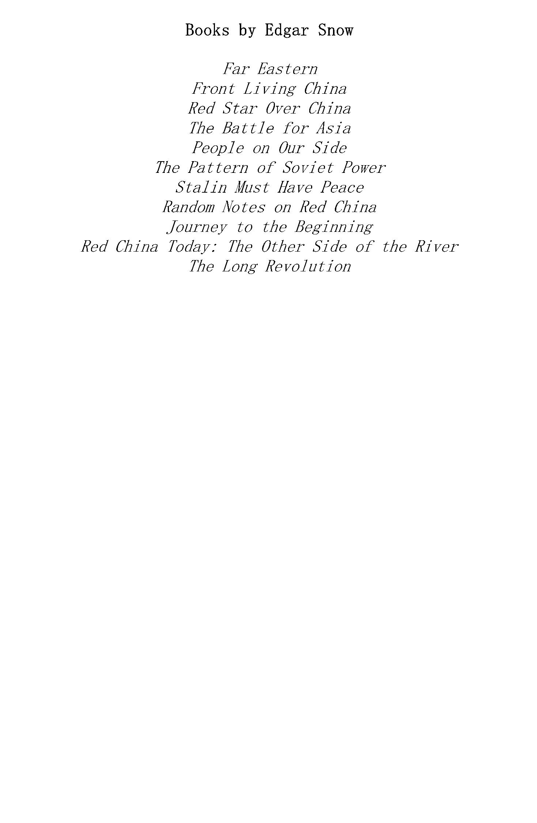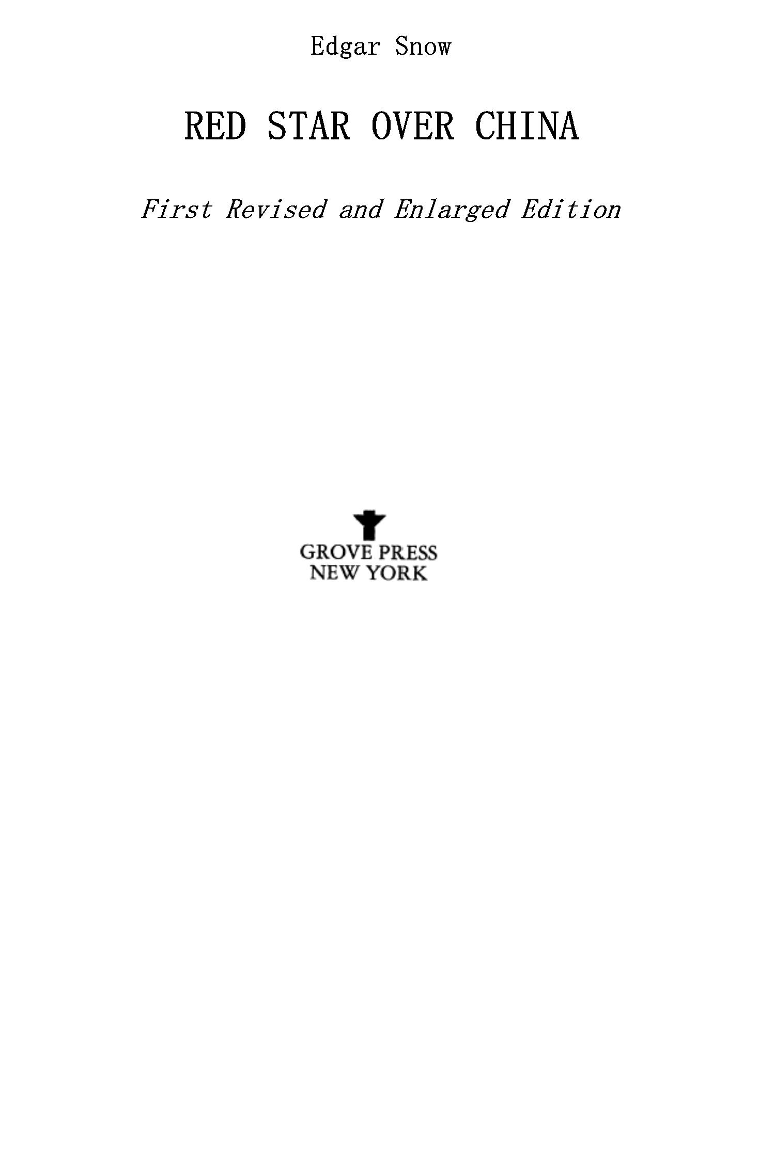

Copyright © 1938, 1944 by Random House, Inc.

Copyright © 1961 by John K. Fairbank

Copyright © 1968 by Edgar Snow

All rights reserved. No part of this book may be reproduced

in any form or by any electronic or mechanical means, or the

facilitation thereof, including information storage and

retrieval systems, without permission in writing from the

publisher, except by a reviewer, who may quote brief

passages in a review. Any members of educational

institutions wishing to photocopy part or all of the work

for classroom use, or publishers who would like to obtain

permission to include the work in an anthology, should send

their inquiries to Grove/Atlantic, Inc., 841 Broadway, New

York, NY 10003.

Library of Congress Catalog Card Number 68-17724

eBook ISBN-13: 978-0-8021-9610-1

Grove Press

an imprint of Grove/Atlantic, Inc.

841 Broadway

New York, NY 10003

Distributed by Publishers Group West

[www.groveatlantic.com](http://www.groveatlantic.com/)

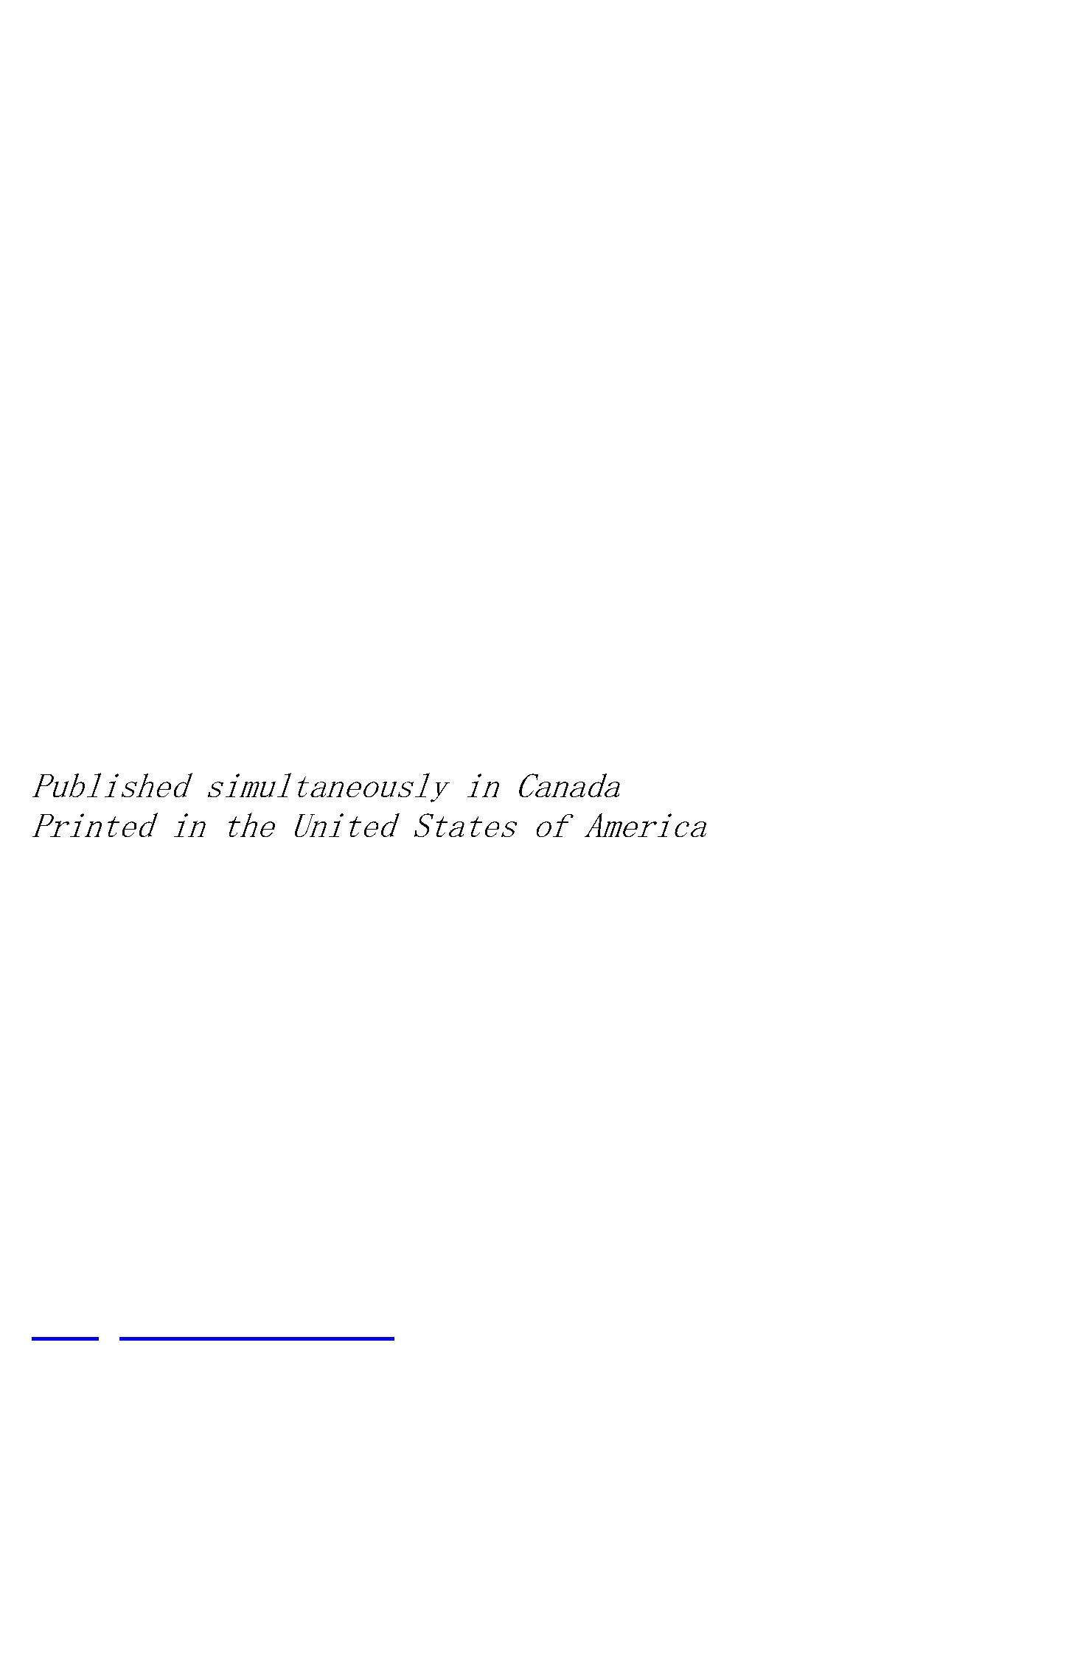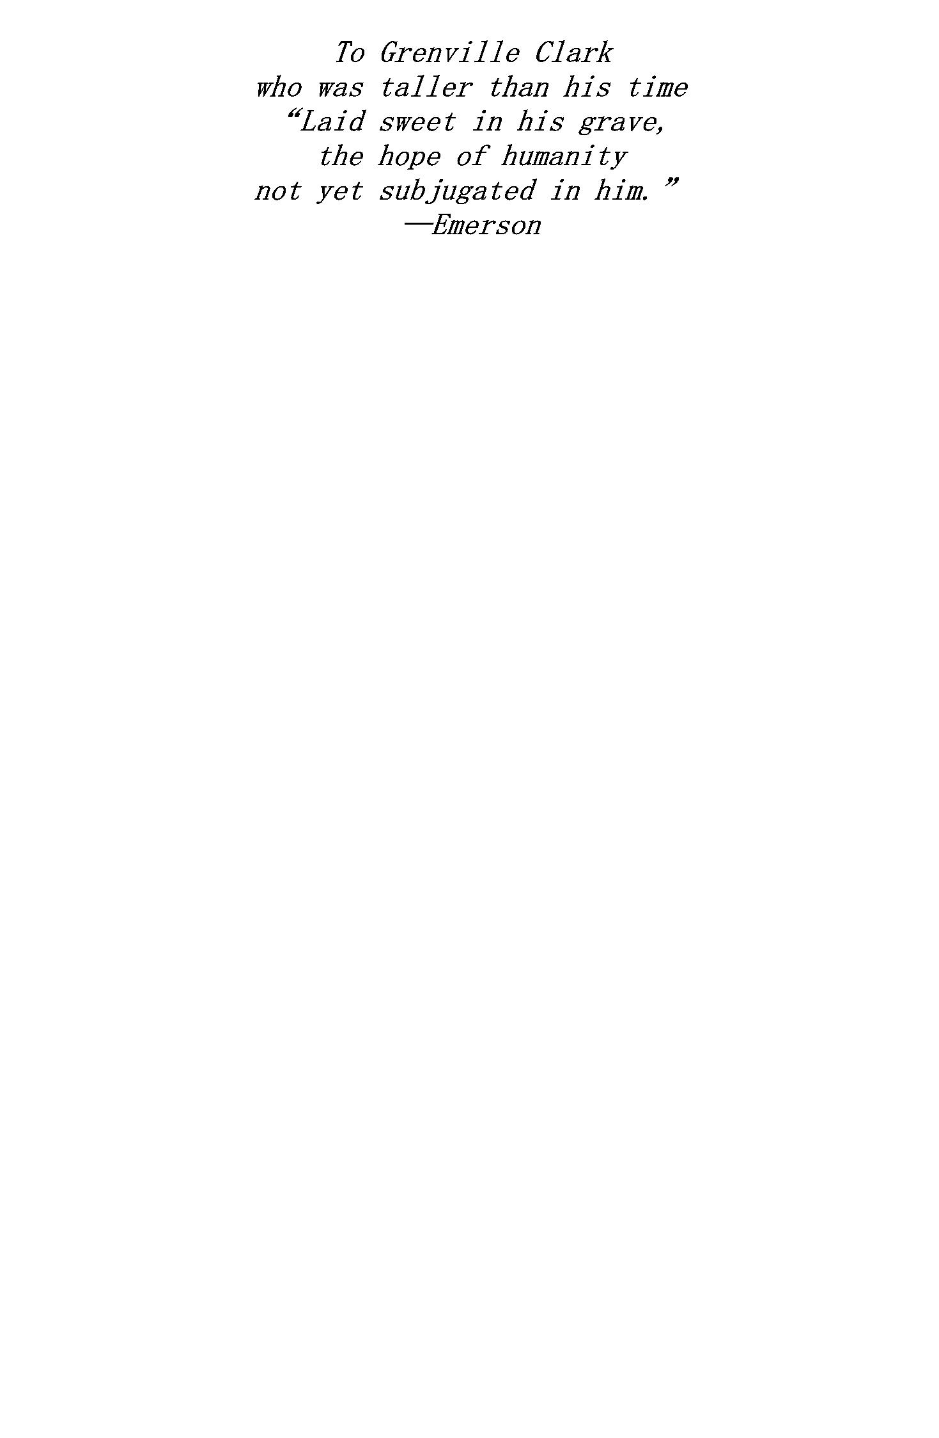

A

PART ONE: IN SEARCH OF RED CHINA

1. Some Unanswered Questions

2. Slow Train to “Western Peace”

3. Some Han Bronzes

4. Through Red Gates

PART TWO: THE ROAD TO THE RED CAPITAL

1. Chased by White Bandits

2. The Insurrectionist

3. Something About Ho Lung

4. Red Companions

PART THREE: IN “DEFENDED PEACE”

1. Soviet Strong Man

2. Basic Communist Policies

3. On War with Japan

4. $2,000,000 in Heads

5. Red Theater

PART FOUR: GENESIS OF A COMMUNIST

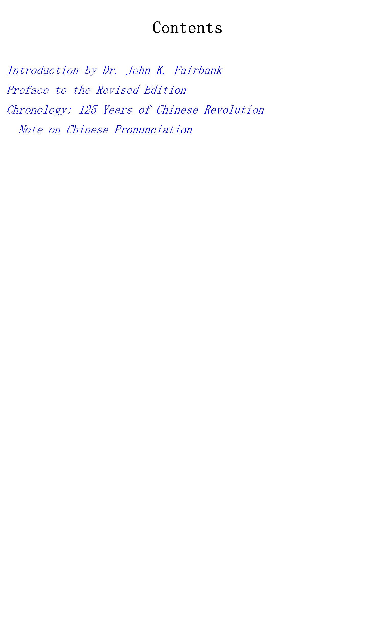

1. Childhood

2. Days in Changsha

3. Prelude to Revolution

4. The Nationalist Period

5. The Soviet Movement

6. Growth of the Red Army

PART FIVE: THE LONG MARCH

1. The Fifth Campaign

2. A Nation Emigrates

3. The Heroes of Tatu

4. Across the Great Grasslands

PART SIX: RED STAR IN THE NORTHWEST

1. The Shensi Soviets: Beginnings

2. Death and Taxes

3. Soviet Society

4. Anatomy of Money

5. Life Begins at Fifty!

PART SEVEN: EN ROUTE TO THE FRONT

1. Conversation with Red Peasants

2. Soviet Industries

3. “They Sing Too Much”

PART EIGHT: WITH THE RED ARMY

1. The “Real” Red Army

2. Impression of P’eng Teh-huai

3. Why Is a Red?



4. Tactics of Partisan Warfare

5. Life of the Red Warrior

6. Session in Politics

PART NINE: WITH THE RED ARMY (Continued)

1. Hsu Hai-tung, the Red Potter

2. Class War in China

3. Four Great Horses

4. Moslem and Marxist

PART TEN: WAR AND PEACE

1. More About Horses

2. “Little Red Devils”

3. United Front in Action

4. Concerning Chu Teh

PART ELEVEN: BACK TO PAO AN

1. Casuals of the Road

2. Life in Pao An

3. The Russian Influence

4. Chinese Communism and the Comintern

5. That Foreign Brain Trust

6. Farewell to Red China

PART TWELVE: WHITE WORLD AGAIN

1. A Preface to Mutiny

2. The Generalissimo Is Arrested

3. Chiang, Chang, and the Reds

4. “Point Counter Point”



5. Auld Lang Syne?

6. Red Horizons

1944

Notes to

APPENDICES

Further Interviews with Mao Tse-tung

Biographical Notes

Leadership in the Chinese Communist Party

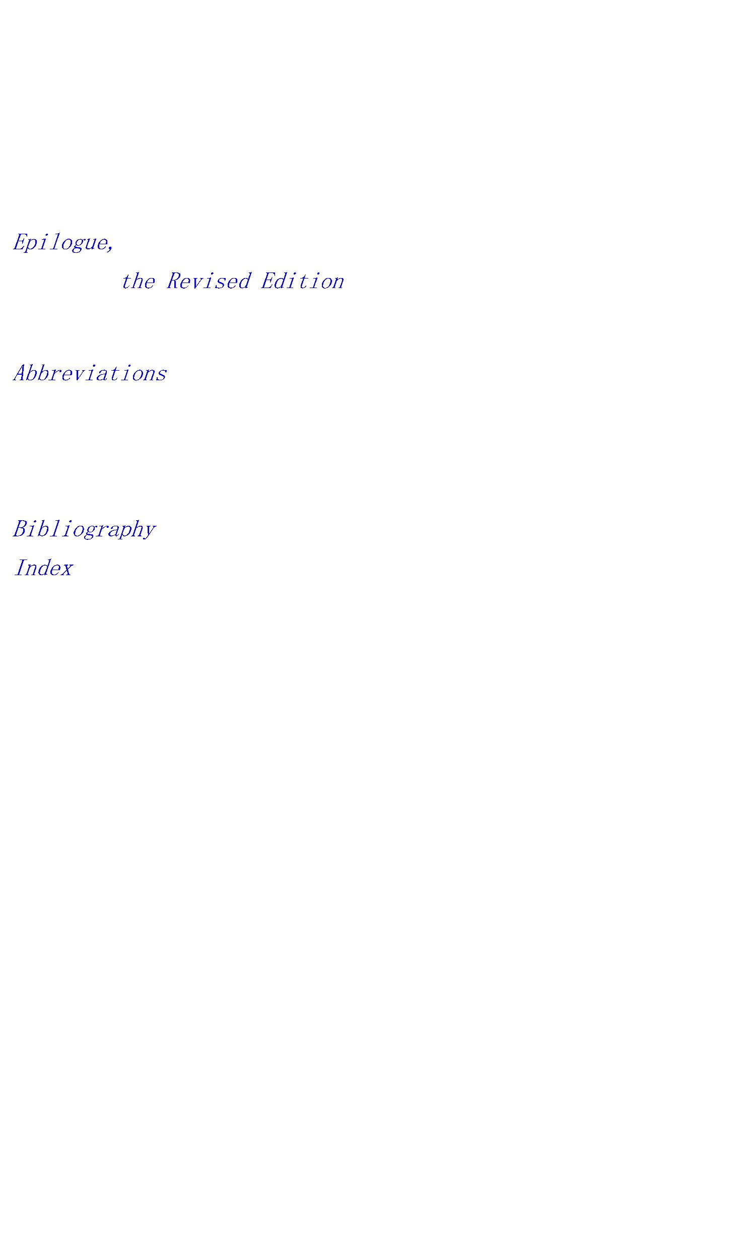

is a classic because of the way in which

it was produced. Edgar Snow was just thirty and had spent

seven years in China as a journalist. In 1936 the Chinese

Communists had just completed their successful escape from

Southeast China to the Northwest, and were embarking upon

their united-front tactic. They were ready to tell their

story to the outside world. Snow had the capacity to report

it. Readers of the book today should be aware of this

combination of factors.

Edgar Snow was born in Kansas City in 1905, his forebears

having moved westward by degrees from North Carolina to

Kentucky and then into Kansas territory. In 1928 he started

around the world. He reached Shanghai, became a journalist,

and did not leave the Far East for thirteen years. Before he

made his trip to report the Chinese Communists, he had

toured through famine districts in the Northwest, traversed

the route of the Burma Road ten years before it was

operating, reported the undeclared war at Shanghai in 1932,

and become a correspondent for the

He

had become a friend of Mme. Sun and had met numerous Chinese

intellectuals and writers. Settling in Peking in 1932, he

and his wife lived near Yenching University, one of the

leading Christian colleges which had been built up under

American missionary auspices. As energetic and wide-awake

young Americans, the Snows had become widely acquainted with

the Chinese student movement against Japanese aggression in

late 1935. They had studied Chinese and developed a modest

fluency in speaking. In addition to publishing his account

of the Japanese aggression,

Front, Edgar Snow

had also edited a collection of translations of modern

Chinese short stories,

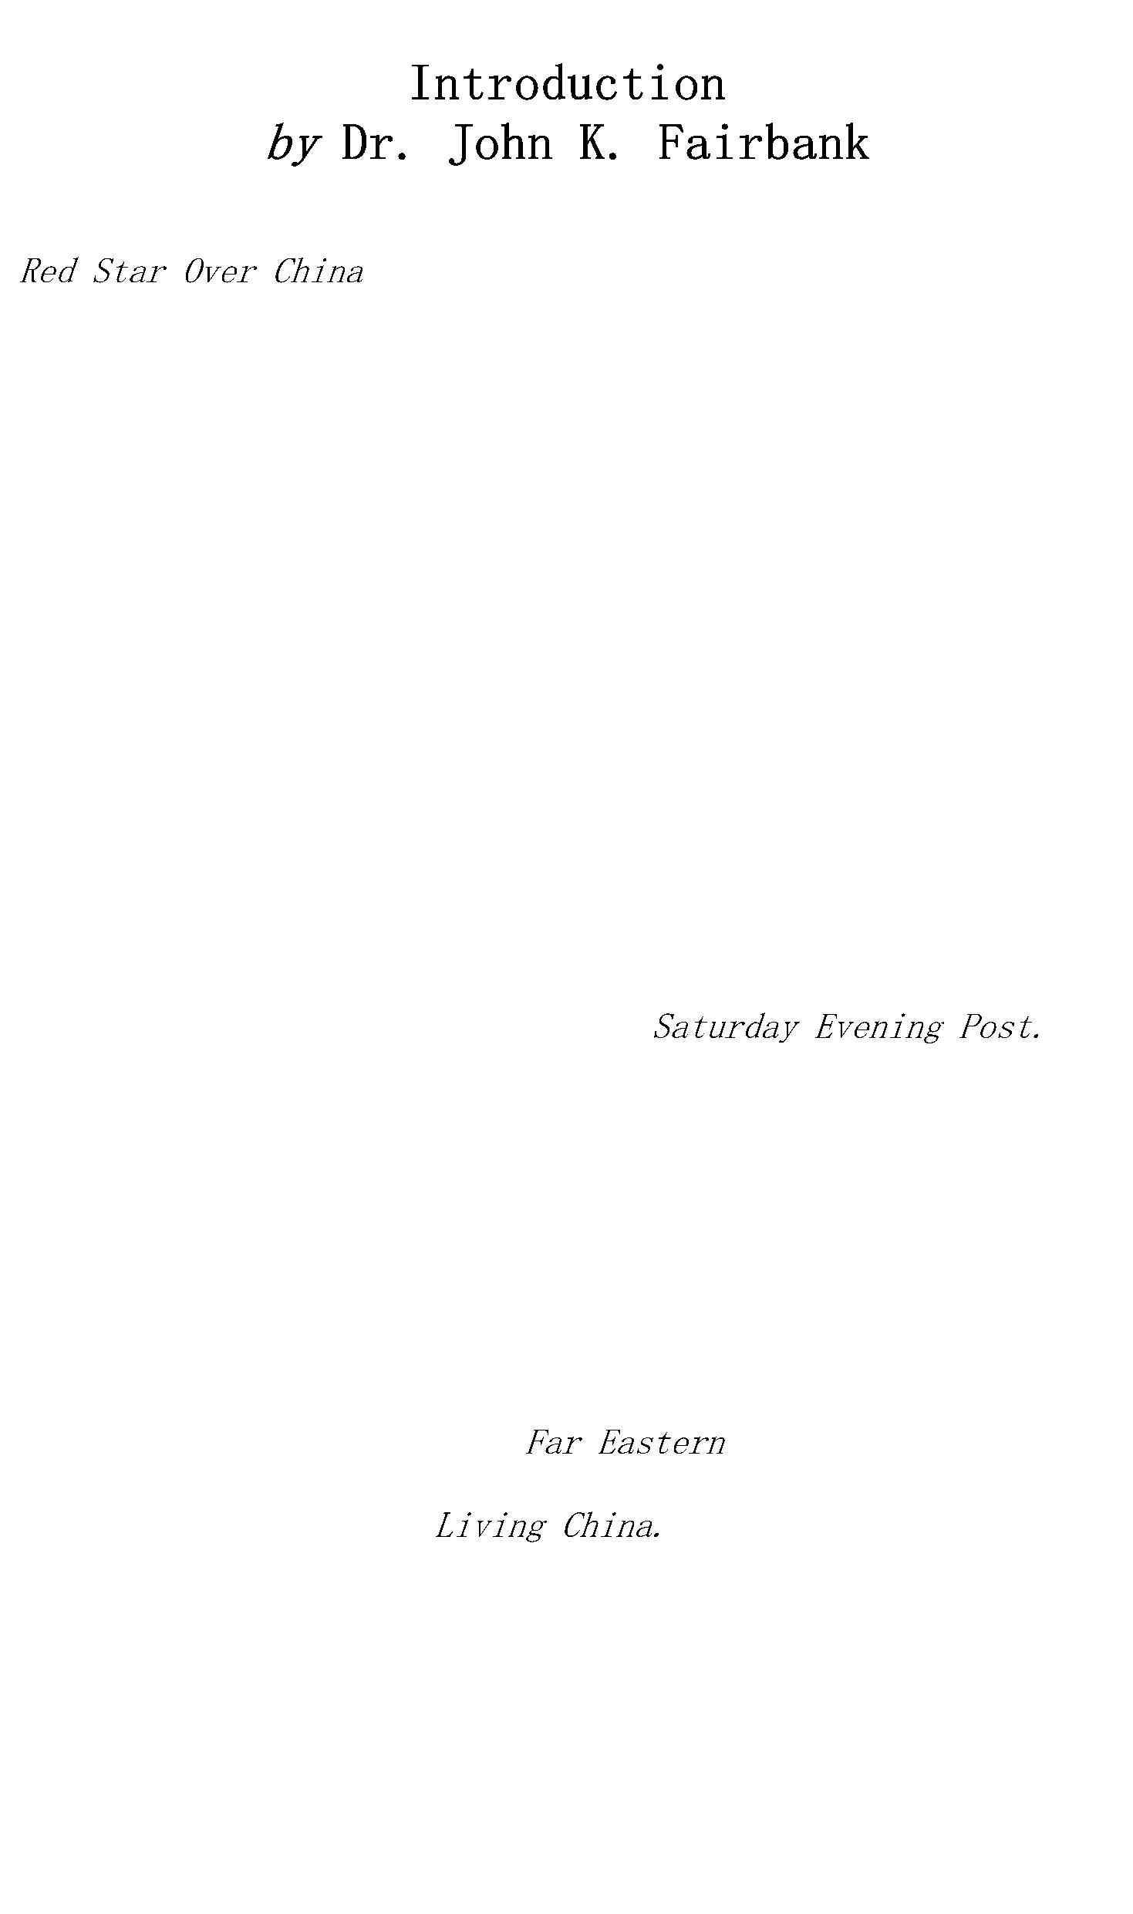

Thus in the period when the Japanese expansion over

Manchuria and into North China dominated the headlines, this

young American had not only reported the events of the day

but had got behind them into some contact with the minds and

feelings of Chinese patriotic youth. He had proved himself a

young man of broad human sympathy, aware of the

revolutionary stirrings among China’s intellectuals, and

able to meet them with some elementary use of the Chinese

language. More than this, Ed Snow was an activist, ready to

encourage worthy causes rather than be a purely passive

spectator. Most of all, he had proved himself a zealous

factual reporter, able to appraise the major trends of the

day and describe them in vivid color for the American

reading public.

In 1936 he stood on the western frontier of the American

expansion across the Pacific toward Asia, which had reached

its height after a full century of American commercial,

diplomatic, and missionary effort. This century had produced

an increasing American contact with the treaty ports, where

foreigners still retained their special privileges.

Missionaries had pushed into the rural interior among

China’s myriad villages and had inspired and aided the

first efforts at modernization. In the early 1930’s

American foundations and missionaries both were active in

the movement for “rural reconstruction,” the remaking of

village life through the application of scientific

technology to the problems of the land. At the same time,

Chinese students trained in the United States and other

Western countries stood in the forefront of those modern

patriots who were becoming increasingly determined to resist

Japanese aggression at all costs. Western-type nationalism

thus joined Western technology as a modern force in the

Chinese scene, and both had been stimulated by the American

contact.

Despite all these developments, however, the grievous

problems of China’s peasant villages had only begun to be

attacked under the aegis of the new Nationalist Government



at Nanking. Harassed by Japanese aggression, Chiang Kai-shek

and the Kuomintang were absorbed in a defense effort which

centered in the coastal treaty ports and lower Yangtze

provinces, with little thought or motive for revolutionary

change in the rural countryside. Meanwhile, in 1936, the

Chinese Communists were known generally as “Red bandits,”

and no Western observer had had direct contact with their

leadership or reported it to the outside world. With the

hindsight of a third of a century, it may seem to us now

almost incredible that so little could have been known about

Mao Tse-tung and the movement which he headed. The Chinese

Communist Party had a history of fifteen years when Edgar

Snow journeyed to its head quarters, but the disaster which

had overtaken it in the 1920’s had left it in a precarious

state of weakness.

When he set out for the blockaded Red area in the

Northwest in June, 1936, with an introduction from Mme. Sun

Yat-sen, he had an insight into Chinese conditions and the

sentiments of Chinese youth which made him almost uniquely

capable of perceiving the powerful appeal which the Chinese

Communist movement was still in the process of developing.

Through the good will of the Manchurian army forces at Sian,

who were psychologically prepared for some kind of united

front with the Communists, Snow was able to cross the lines,

reach the Communist capital, then at Pao An (even farther in

the Northwest than the later capital at Yenan), and meet Mao

Tse-tung just at the time when Mao was prepared to put

himself on record.

After spending four months and taking down Mao Tse-tung’s

own story of his life as a revolutionist, Snow came out of

the blockaded Red area in October, 1936. He gave his eye-

opening story to the press in articles, and finished

on the basis of his notes in July, 1937.

The remarkable thing about

was that it

not only gave the first connected history of Mao and his

colleagues and where they had come from, but it also gave a

prospect of the future of this little-known movement which

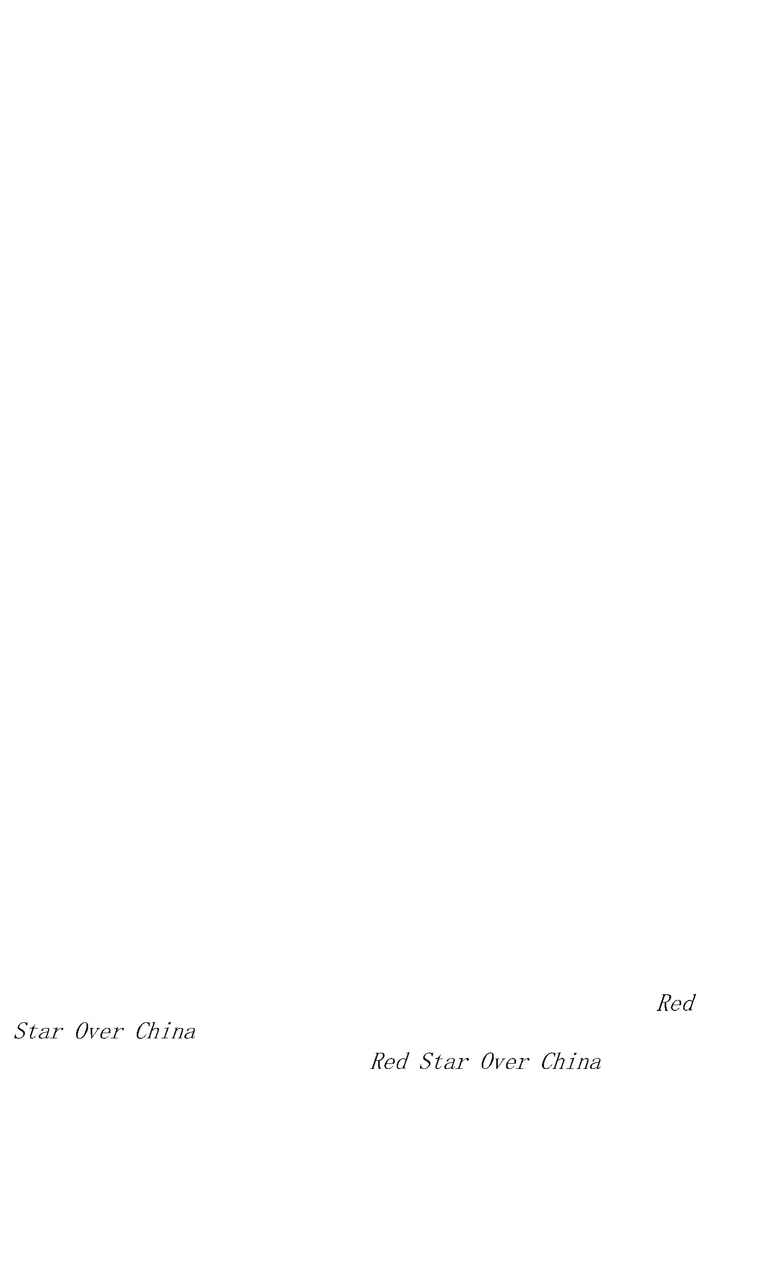

was to prove disastrously prophetic. It is very much to the

credit of Edgar Snow that this book has stood the test of

time on both these counts—as a historical record and as an

indication of a trend.



Travels and events described in this book took place in 1936

and 1937 and the manuscript was completed in July, 1937, to

the sound of gunfire by Japanese troops outside the walls of

Peking, where I lived. Those guns of July in China opened

eight years of Sino-Japanese battle which merged with the

Second World War. The same guns also heralded the ultimate

Communist victory in China which profoundly altered the

balance of power, both inside and outside what was formerly

called “the Communist camp.”

In time and space this report concerned an isolated

fighting force in an area far removed from the West on the

eve of its greatest catastrophe. The League of Nations had

been destroyed when it failed to halt Japan’s conquest of

Manchuria in 1931–33. In 1936 the Western “Allies”

permitted Hitler, still a cardboard Napoleon, to reoccupy

the Rhineland without a fight. They impotently watched

Mussolini seize Ethiopia. They then imposed an arms embargo

against Spain under the hypocrisy of neutralism, which

denied the Republic the means to defend itself against

reactionary generals led by Franco, who had the open support

of thousands of imported Nazi and Fascist troops and planes.

They thus encouraged Hitler and Mussolini to form an

alliance ostensibly aimed at Russia but clearly intended to

subjugate all of Western Europe. In 1938 Hitler was allowed

to swallow Austria. He was then rewarded, by Chamberlain and

Daladier, with Czechoslovakia as the price of “peace in our

time.” In compensation they soon received the Hitler-Stalin

pact.

Such was the international environment of China when this

journey was undertaken. Domestic conditions inside that

disintegrating society are defined in the text. In 1936 I

had already lived in China for seven years and I had, as a



foreign correspondent, traveled widely and acquired some

knowledge of the language. This was my longest piece of

reportage on China. If it has enjoyed a more useful life

than most journalism it is because it was not only a

“scoop” of perishable news but likewise of many facts of

durable history. It won sympathetic attention also perhaps

because it was a time when the Western powers, in self-

interest, were hoping for a miracle in China. They dreamed

of a new birth of nationalism that would keep Japan so

bogged down that she would never be able to turn upon the

Western colonies—her true objectives.

tended to show that the Chinese Communists could indeed

provide that

leadership needed for effective

anti-Japanese resistance. How dramatically the United

States’ policy-making attitudes have altered since then is

suggested by recalling that condensations of this report

originally appeared in the

magazine.

and

Other circumstances contributed to prolong the utility of

this book. I had found Mao Tse-tung and other leaders at an

especially favorable moment, in a lull between long years of

battle. They gave me a vast amount of their time, and with

unprecedented frankness provided more personal and

impersonal information than any one foreign scribe could

fully absorb. After my second visit to see Mao Tse-tung, in

1939, all the Red bases in Northwest China were blockaded by

Nationalist troops, in their rear, and cut off by Japanese

occupation around the guerrilla areas. For another five

years, while no foreign newsmen were able to reach Yenan,

the Red capital, these reports remained a unique source.

Much of this work is history seen from a partisan point of

view, of course, but it is history as lived by the men and

women who made it. It provided not only for non-Chinese

readers, but also for the entire Chinese people—including

all but the Communist leaders themselves—the first

authentic account of the Chinese Communist Party and the

first connected story of their long struggle to carry

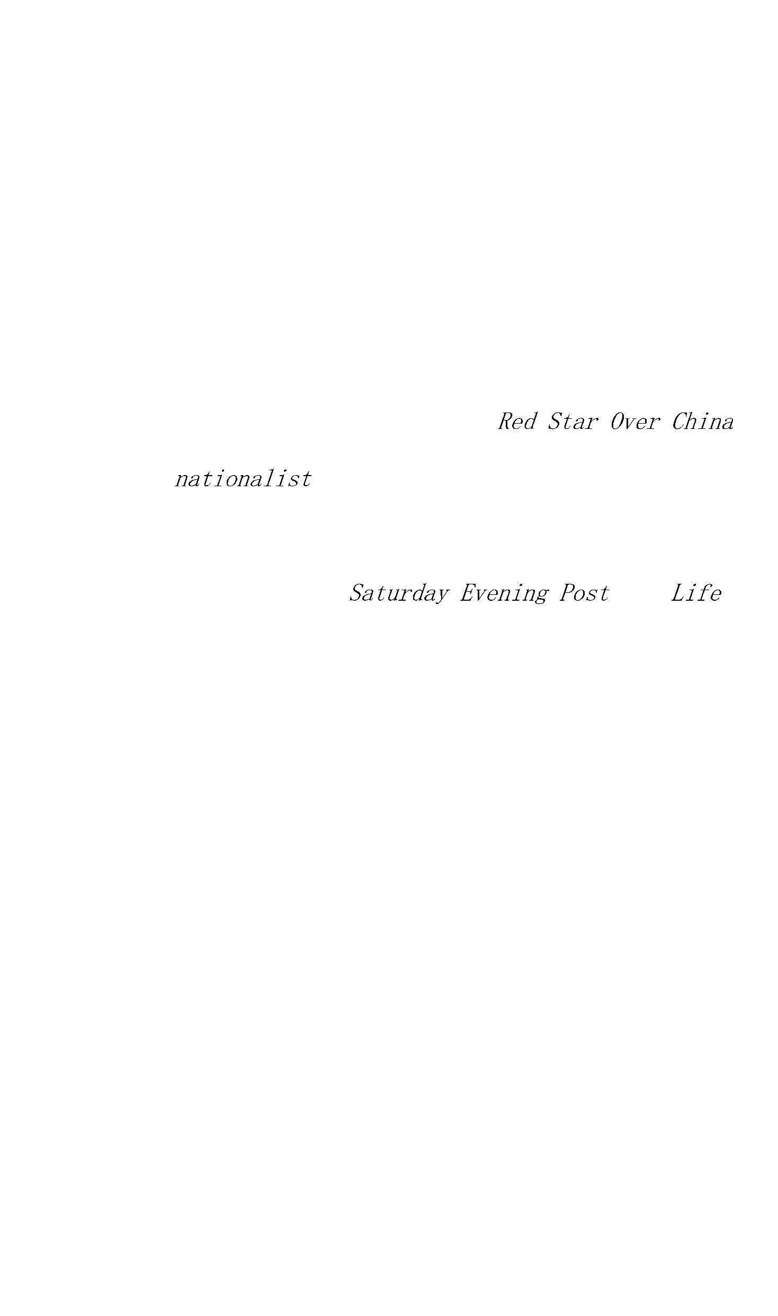

through the most thoroughgoing social revolution in China’s

three millenniums of history. Many editions were published

in China, and among the tens of thousands of copies of the

Chinese translations some were produced entirely in

guerrilla territory.

I do not flatter myself that I had much to do with

imparting to this volume such lessons of international

application as may be drawn from it. For many pages I simply

wrote down what I was told by the extraordinary young men

and women with whom it was my privilege to live at age

thirty, and from whom I learned (or had the chance to learn)

a great deal.,

In 1937, when

first appeared, in

England, there were practically no sources of documentation

for most of the material presented here. Today many foreign

China specialists—helped or led by Chinese scholars of

different political colorations—have produced dozens of

works of varying importance and quality. With an abundance

of new information available, aided by my own and others’

wisdom of hindsight, many improvements might be made in the

text to minimize its limitations—and yet deprive it of

whatever original value it may possess. Therefore it was my

intention to leave it as first written except for

corrections of typographical errors and mistakes of spelling

or of factual detail. That hope has not proved wholly

practicable and departures from its fulfillment are

acknowledged below.

Since

was completed under conditions

of war I did not have the opportunity to see or correct

galley proofs of the first edition. Nor have I been able to

do so with subsequent editions until now. In extenuation for

one kind of mistake: my handwritten field notes contained

many names previously unknown to me, and I could not always

get them down in Chinese characters. Phonetic

transliterations into English resulted in misspellings as

judged by Wade-Giles standards. These have now been (I hope)

uniformly corrected.

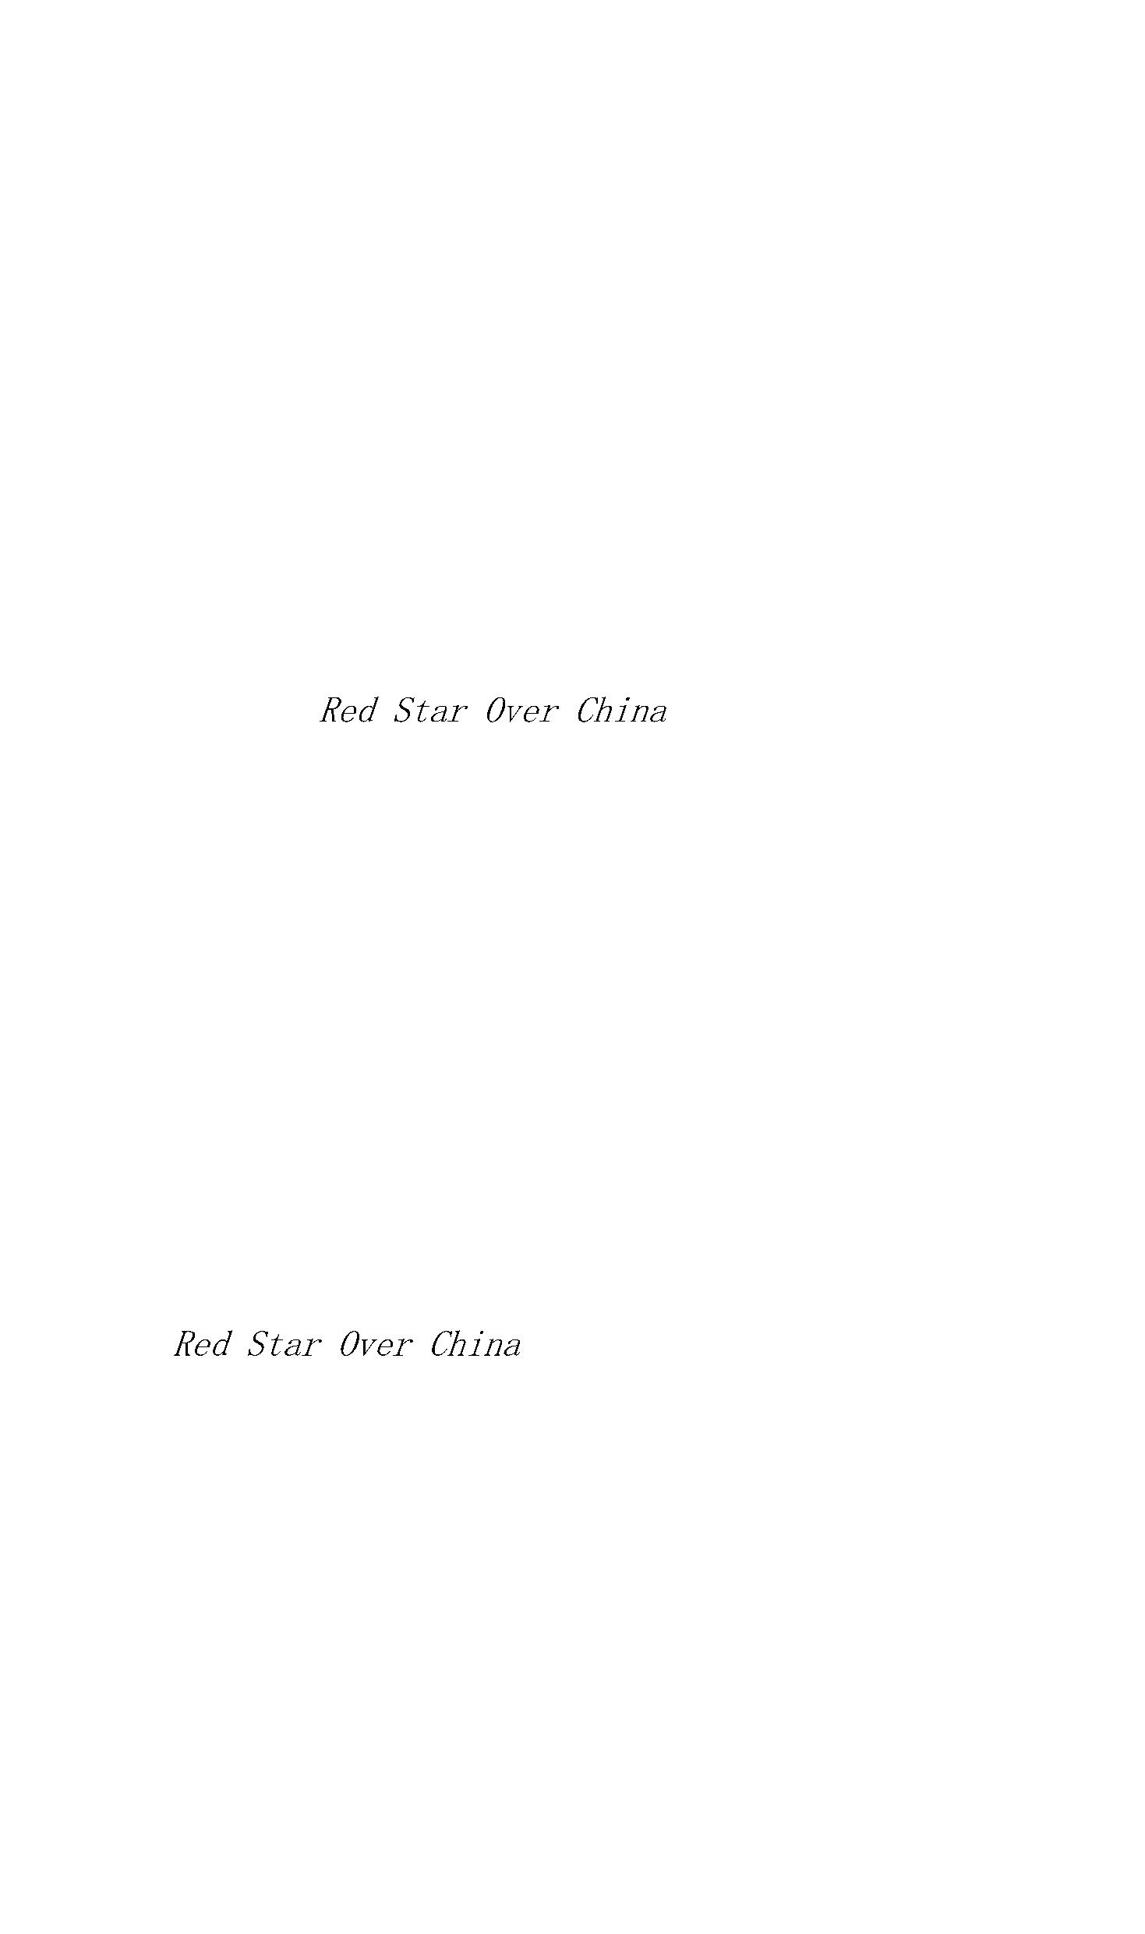

Aside from that kind of conformance I have widely altered

former present-tense verbs to past tense in order to

eliminate many seeming anachronisms and make the story more

accessible to contemporary readers. Where the book quotes or

paraphrases the testimony of others, the wording of the

original text has generally been preserved—to avoid

tampering with

historical material—even when it

conflicts with more believable information now available. In

a few instances where secondary material has been proved

manifestly inaccurate I have cut or corrected, rather than

perpetuate known errors. In either case readers may refer to

the Biographical Notes or the Notes to this edition to

supplement or modify some textual facts or opinions. Here

and there (with a certain macabre sense of looking backward

on myself) I have reworked lines which the passage of time—

or murky writing in the first instance—has made

unintelligible to me. The great bulk of the volume, all the

happenings, the main travel notes, interviews, and Mao Tse-

tung’s—remain intact.

Such liberties as I have taken in shortening, condensing,

or discarding tedious accounts of a few matters no longer of

importance helped to make room for the chronology, an

epilogue, new footnotes, some heretofore unpublished

documents, chapter commentaries, and some fascinating

lessons of history in the form of biographical sequels to

the early life stories of the truly extraordinary people

first introduced here. Cuts of paragraphs and even whole

pages necessitated composing new transitional passages. Such

“spin-ins” are confined to knowledge available to me no

later than 1937, and the same applies to page footnotes—but

not to the end-of-book materials, of course.

Doubtless this tome would not have suffered (and the

reader would have profited) if I had omitted several whole

chapters. Revision was not easy, and I daresay someone less

connected with the subject could have done it with less pain

to himself and with more grace for the reader.



And so, salutations and thanks to all persons mentioned in

this book for their help and permission to use their remarks

and photographs, especially Mao Tse-tung; to John Fairbank,

for taking one more look at these ancient spoor, to Peter J.

Seybolt for a reappraisal against a background of far wider

perspective than we could know in the thirties; to Enrica

Collotti Pischel, for painstaking scholarship in translating

into Italian and bringing up to date the 1965 edition

which inspired this effort; and to

Mary Heathcote, Trudie Schafer, and Lois Wheeler for

assistance and encouragement in general.

Edgar Snow

Geneva, February 14,1968

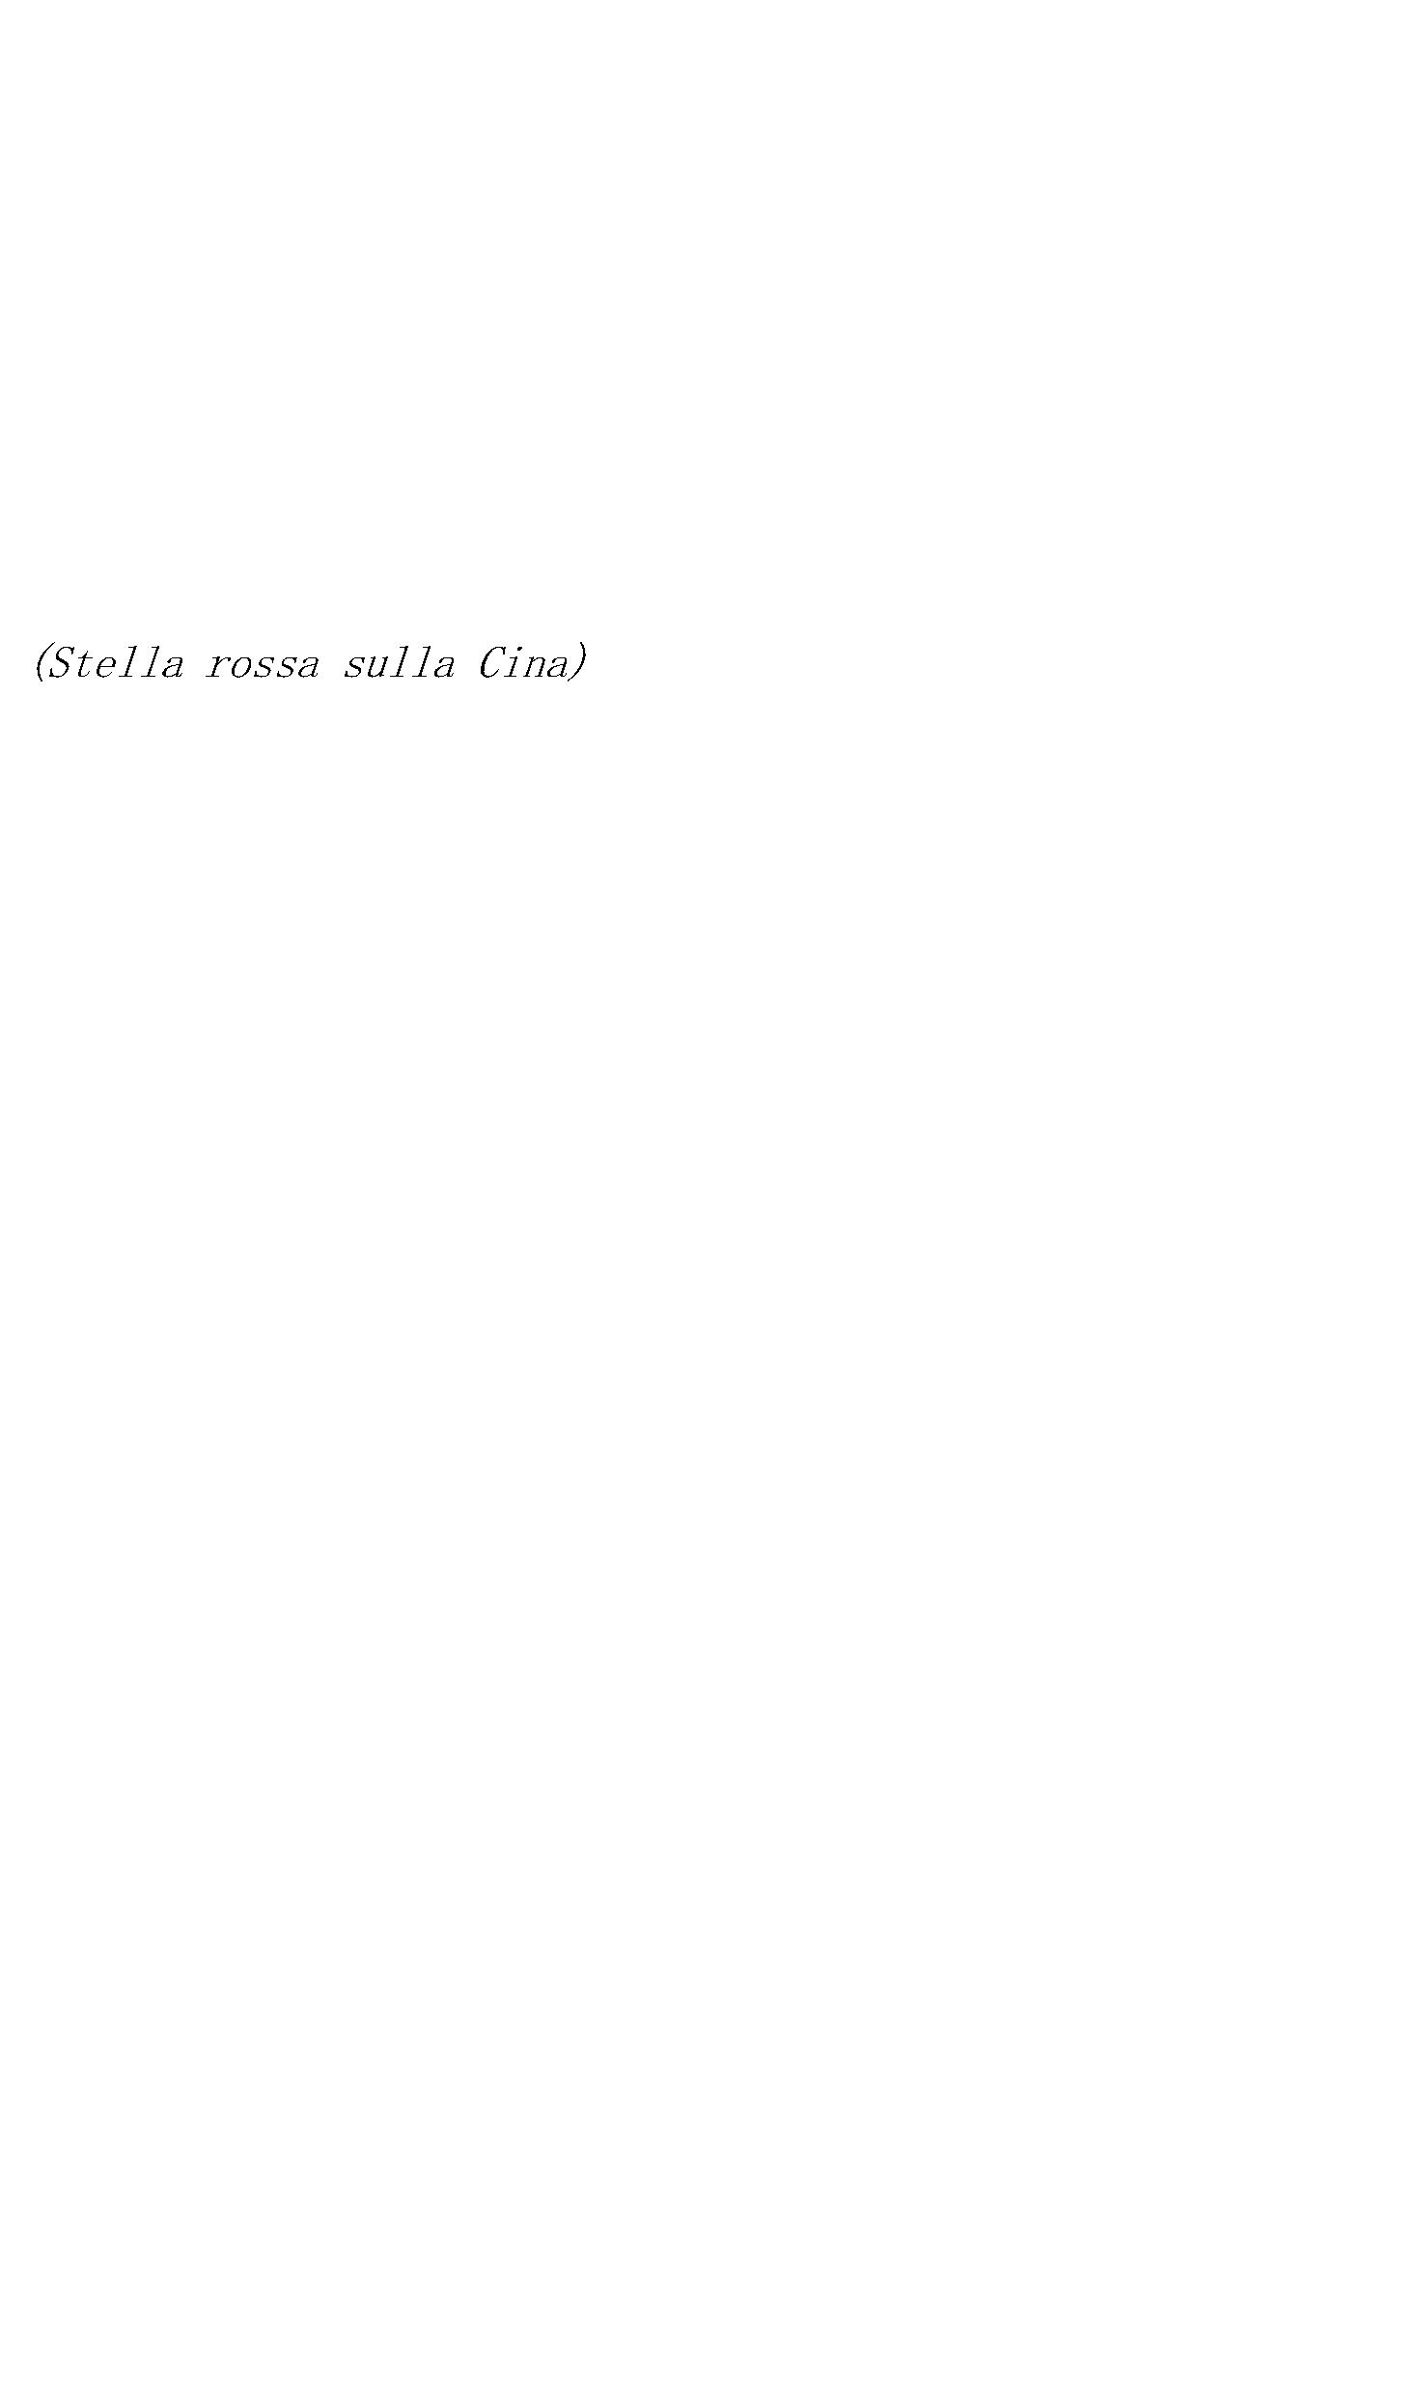

I.

1840–42 The “Opium Wars,” during which Great Britain

forcibly opens China to foreign trade. They are

followed by the granting of territorial concessions and

rights of inland navigation and missionary activity.

The British take Hongkong.

1860 China accepts Russian annexation of eastern Siberia.

1864 Near-victorious T’ai-p’ing (Great Peace) Rebellion

crushed by Sino-Manchu forces under General Tseng Kuo-

fan, helped by British army regulars and mixed European

and American mercenaries. Chinese revolution

“postponed sixty years.” Following French penetration

and seizure of Indochina (1862), encroachments

increasingly reduce the Manchu-Chinese Empire to

semicolonial status.

1866 Sun Yat-sen (founder of Kuomintang, or Nationalist

Party, 1912) born in Kwangtung province.

1868 Czarist Russia annexes Bokhara and begins penetration

toward Chinese Turkestan.

1869 Suez Canal completed.

1870 Lenin born. 1874 Churchill born.

1879 Ch’en Tu-hsiu (first general secretary, 1921–27, of

Kungch’antang, or Chinese Communist Party) born in

Anhui province. Rapid expansion of French and British

colonial empires in Africa.

1883–85 Franco-Chinese War. Chinese troops in Indochina,

defending Peking’s claim to suzerainty there, are

defeated. France also acquires new territorial-

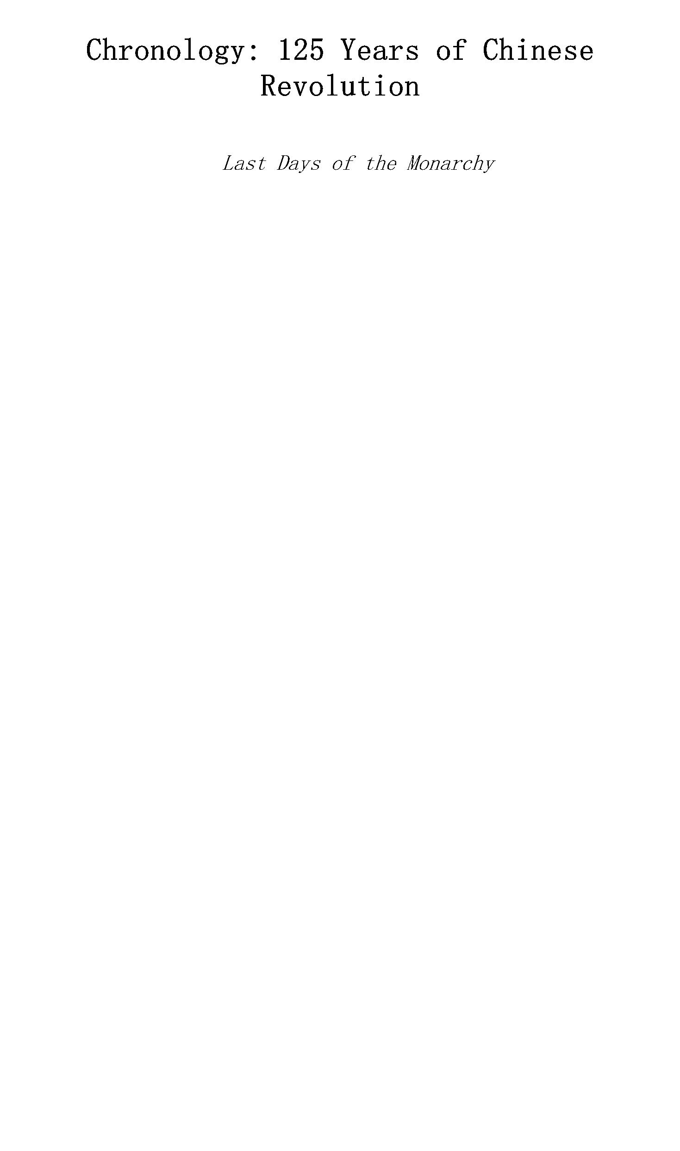

political concessions in China. Britain ends China’s

suzerainty in Burma.

1889 Cecil Rhodes establishes British South African Company.

1893 Mao Tse-tung born in Hunan province. France extends its

Indo-chinese colonial power to Laos and Cambodia.

1894–95 Sino-Japanese War. China forced to cede Taiwan

(Formosa) to Japan and abandon ancient claims to

suzerainty over Korea.

1898 “Hundred Days Reform” under Emperor Kuang Hsu.

Empress Dowager Tz’u Hsi imprisons Kuang Hsu and

returns to power, to remain real ruler till her death

(1909). United States defeats Spain, takes Philippines.

1899 “Open Door” doctrine proclaimed by U.S.A.; “equal

opportunity” for foreign powers in the economic and

commercial “development” of China.

1900 So-called Boxer Rebellion. Antiforeign uprising. Allied

reprisals include mass executions, crushing

indemnities, new concessions, legalized foreign

garrisons between Tientsin and Peking, etc. Czarist

Russia takes China’s port of Talien (Dairen), builds

naval base (Port Arthur), acquires railway concessions

across China’s three northeastern provinces

(Manchuria). Mao Tse-tung works as laborer on his

father’s farm.

1902 Anglo-Japanese alliance.

1901–05 Russo-Japanese War. Japan gets Port Arthur, Dairen,

Russia’s concessions in South Manchuria (China), and

additional “rights.” Dr. Sun Yat-sen forms

revolutionary Alliance Society in Tokyo.

1905 First Russian Revolution.

1911 Republican revolution (the “First Revolution”)

overthrows Manchu power in Central and South China. At

Nanking, Sun Yat-sen declared president of provisional

government, first Chinese Republic. Student Mao Tse-



tung joins rebel army; resigns after six months,

thinking “revolution over.”

II.

1912 Rulers of Manchu Dynasty formally abdicate. Sun Yat-sen

resigns in favor of Yuan Shih-k’ai, as president of

the Republic of China. Peking is its capital.

Kuomintang (Nationalists) dominates first parliament,

forms cabinet. Italy takes Libya.

1912–14 Provisional constitution and parliament suspended

by militarist Yuan Shih-k’ai, who becomes dictator.

Japan imposes “Twenty-one Demands,” their effect to

reduce China to vassal state. Yuan Shih-k’ai accepts

most of the demands. Cabinet resigns. European war

begins. Japan seizes Tsingtao, German colony in China.

Mao first studies books by Western scholars.

1915

magazine, founded by

Ch’en Tu-hsiu, becomes focus of revolutionary youth,

and popularizes written vernacular

death knell of Confucian classicism. Mao Tse-tung

becomes contributor, under pseudonym. Yuan

language;

Shih-k’ai attempts to re-establish monarchy, with

himself as emperor.

1916 Second (Republican) Revolution: overthrow of

“Emperor” Yuan Shih-k’ai by “revolt of the

generals” led by Tsai O. Nullification of Yuan’s

acceptance of Japan’s “Twenty-one Demands.” Era of

warlords begins.

1917 Peking “shadow government” declares war on Germany.

Generalissimo Sun Yat-sen, heading separate provisional

regime in Canton, also declares war. In Hunan, Mao Tse-

tung becomes co-founder of radical youth group, New

People’s Study Society. The October Revolution occurs

in Russia.

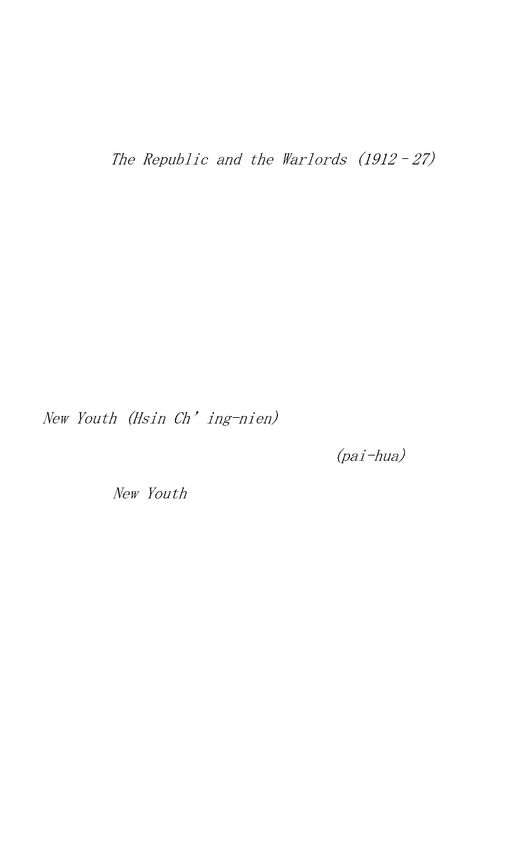

1918 End of First World War. Mao Tse-tung graduates from

Hunan First Normal School, aged twenty-five. He visits

Peking; becomes assistant to Li Ta-chao, librarian of

Peking University. Li Ta-chao and Ch’en Tu-hsiu

establish Marxist study society, which Mao joins. All

three later become founders of Chinese Communist Party.

1918–19 175,000 laborers sent overseas to help allies; 400

“Work-Study” student interpreters include Chou En-

lai. Mao Tse-tung accompanies students to Shanghai.

Back in Hunan, Mao founds

, anti-

imperialist, antimilitarist, pro-Russian Revolution.

1919 May Fourth Movement. Nationwide student demonstrations

against Versailles Treaty award of Germany’s China

concessions to Japan. Beginning of modern nationalist

movement. Hungarian (Bela Kun) Communist-led social

revolution suppressed.

1920 Mao Tse-tung organizes Hunan Branch of Socialist Youth

Corps; among its members, Liu Shao-ch’i. Mao marries

Yang K’ai-hui, daughter of his esteemed ethics

professor at normal school. Mao helps found Cultural

Book Study Society. League of Nations established.

1921 Chinese Communist Party formally organized at First

Congress, Shanghai. Mao participates; is chosen

secretary of CP of Hunan. Ts’ai Ho-sen, Chou En-lai,

and others form Communist Youth League in Paris.

Revolution in Mongolia.

1922 Sun Yat-sen agrees with Lenin’s representative to

accept Soviet aid and form united front with CCP;

Communists may now hold joint membership in Kuomintang,

led by Sun. Washington Conference restores Germany’s

colony to China.

III.

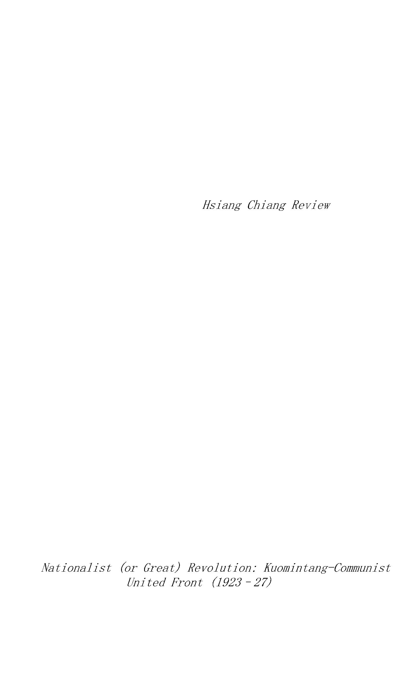

1923 Agreement between Sun Yat-sen and Adolf Joffe provides

basis for KMT-CCP-CPSU alliance. At Third Congress of

CCP, in Canton, Mao Tse-tung elected to Central

Committee and chief of organization bureau.

1924 First Congress of Kuomintang approves admission of

Communists. Mao Tse-tung elected an alternate member,

Central Executive Committee, Kuomintang. Lenin dies.

1925 Mao returns to Hunan, organizes peasant support for

Nationalist (Liberation) Expedition. Writes his first

“classic,”

(published 1926). Sun Yat-sen dies. Russian advisers

choose Chiang Kai-shek as commander-in-chief.

“Universal suffrage” in Japan.

1926 Nationalist Revolutionary Expedition launched from

Canton under supreme military command of Chiang Kai-

shek. Mao, back in Canton, becomes deputy director

Kuomintang Peasant Bureau and Peasant Movement Training

Institute; he heads agit-prop department. Nationalist-

Communist coalition forces conquer most of South China.

Communist-led Indonesian revolution suppressed by

Dutch.

IV.

1927 Stalin victorious over Trotsky. In March, Mao Tse-tung

publishes his Report

calls poor peasants “main

force” of revolution, demands confiscation of

landlords’ land. Thesis rejected by Communist Party

Central Committee. In April, Chiang Kai-shek leads

anti-Communist coup, “beheads Party”; Communist

membership reduced, by four-fifths, to 10,000. Ch’en

Tu-hsiu deposed as CCP secretary. Party driven

underground. Mao leads peasant uprising in Hunan

(August); defeated, he flees to mountain stronghold,

Chingkangshan. Nanchang Uprising also defeated. Retreat

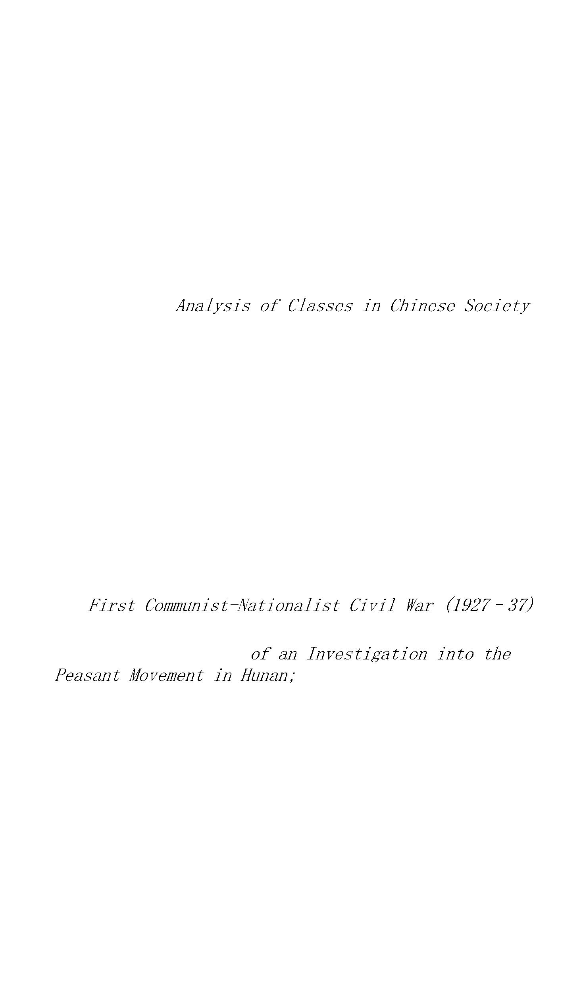

to countryside. Canton (Commune) Uprising fails. P’eng

P’ai leads survivors to Hailufeng and sets up

Hailufeng Soviet (1927). Sukarno forms Indonesian

Nationalist Party.

1928 Chiang Kai-shek establishes nominal centralized control

over China under National Government (a Kuomintang,

one-party dictator ship). Mao Tse-tung and Chu Teh join

forces at Chingkangshan, Hunan, form first “Red Army”

of China and local soviet. Paris Peace Pact signed by

the great powers, renouncing war “as an instrument of

national policy.”

1929 Mao Tse-tung and Chu Teh conquer rural territories

around Juichin, Kiangsi, where a soviet government is

proclaimed. Communist Politburo, dominated by Li Li-

san, remains hidden in foreign-controlled Shanghai.

Stock market crash in New York.

1930 Conflict between Mao’s “rural soviet movement” and

Politburo leader Li Li-san, who favors urban

insurrections. Red Army led by Mao and P’eng Teh-huai

captures Changsha, capital of Hunan, then withdraws.

Second assault on Changsha a costly failure. Li Li-san

discredited by Moscow. Chiang Kai-shek launches first

major offensive against the Reds. Mao Tse-tung’s wife

and sister executed in Changsha. Gandhi leads

nonviolent civil disobedience in India.

1931 Spain declares a Republic. Meeting underground in

January, in Shanghai, Central Committee of CCP elects

Wang Ming (Ch’en Shao-yu) general secretary and chief

of Party. All-China Congress of Chinese Soviets,

convened in deep hinterland at Juichin, elects Mao Tse-

tung chairman of the first All-China Soviet Government,

Chu Teh military commander. In September, Japan begins

conquest of Manchuria; Chiang Kai-shek suspends his

third “annihilation campaign” against Red Army. End

of Great Famine (1929–31) in Northwest China;



estimated dead, five to ten million. Wang Ming goes to

Moscow. Po Ku heads Shanghai Politburo.

1932 Japan attacks Shanghai, defended by Nineteenth Route

Army; unsupported by Chiang Kai-shek, it retreats to

Fukien province. Chiang authorizes Tangku Truce, to end

Sino-Japanese hostilities. He renews offensive against

Kiangsi Soviet; Reds declare war on Japan. Police in

Shanghai International Settlement help Chiang Kai-shek

extirpate Red underground. Politburo chiefs Po Ku, Lo

Fu, Liu Shao-ch’i, and Chou En-lai join Mao in Kiangsi

Soviet. Roosevelt elected President of U.S.

1933 Nineteenth Route Army rebels and offers alliance to

Reds, which is rejected. Chiang Kai-shek destroys

Nineteenth R.A., begins a new campaign against Soviet

China. Hitler becomes chancellor of Germany.

1934 Second All-China Soviet Congress re-elects Mao Tse-tung

chairman, but Party leadership falls to “Twenty-eight

Bolsheviks.” Red Army changes tactics and suffers

decisive defeats. Main forces and party cadres retreat

to West China.

1935 Politburo meets in Tsunyi, Kweichow, in January; elects

Mao Tse-tung effective leader of the Party and army

during Long March to Northwest China. In July, Kiangsi

Red forces reach Szechuan and join troops under

Politburo member and Party co-founder Chang Kuo-t’ao,

driven from soviet areas north of Yangtze River. In

enlarged meeting of Politburo, Chang Kuo-t’ao disputes

Mao’s policy and leadership. Red forces divide; Mao

leads southern forces into new base in Northwest China,

after one year of almost continuous marching, totaling

6,000 miles. (Chang Kuo-t’ao follows him a year

later.) Japan demands separation of two North China

provinces, under “autonomous” regime. Japanese troops

move into Chinese Inner Mongolia, set up bogus

“independent” state. December 9 student rebellion in



Peking touches off wave of anti-Japanese national

patriotic activity. Italy seizes Ethiopa.

1936 Mao Tse-tung, interviewed by the author in Pao An,

Shensi, tells his life story and his account of the

revolution, and offers to end civil war to form a

united front against Japan. Mao lectures to the Red

Army University; his

and

become doctrinal basis of new stage

of united front against Japan. Spurning Communists’

offer of a truce (first made on August 1, 1935), Chiang

Kai-shek mobilizes for “final annihilation” of Reds

in Northwest.

The Sian Incident, in December: Chiang Kai-shek

“arrested” by his deputy commander-in-chief, Chang

Hsueh-liang, exiled Man-churian leader. Marshal Chang

insists that Chiang accept national united front

against Japan. Following Chiang Kai-shek’s release,

and undeclared truce in civil war, Kuomintang opens

negotiations with CCP and its “anti-Japanese

government” based in Yenan, Shensi.

V.

1937 In July, Japan massively invades China. Agreement

signed for joint Nationalist-Communist war of

resistance against Japan. Chinese Soviet Government

dissolved but continues as autonomous regional regime;

Red Army becomes Eighth Route and New Fourth armies

under Chiang’s nominal command. Mao writes theoretical

works,

and On

Italy leaves

the League of Nations.

1938 Mao outlines Communists’ wartime political and

military ends and means in

and

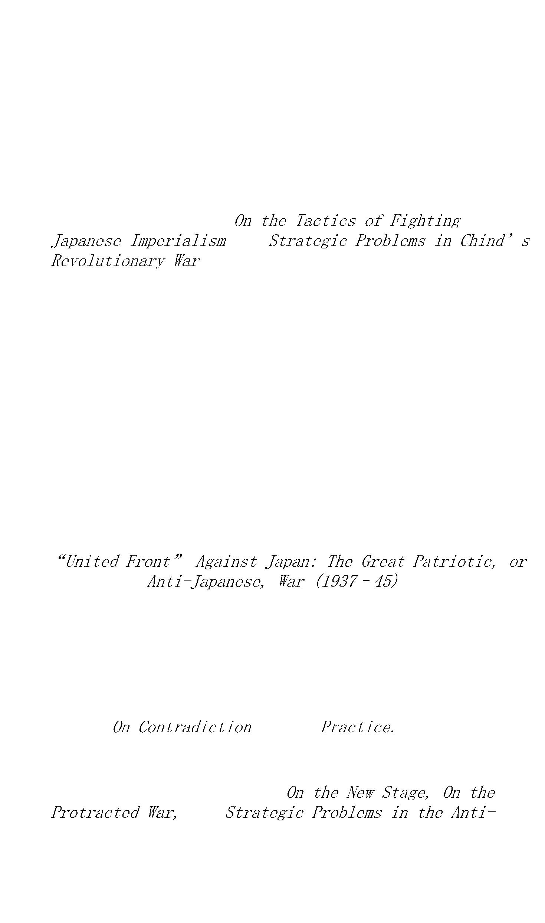

Chang Kuo-t’ao, expelled from

the CCP, enters Kuomintang areas. Mao becomes un

disputed leader of Party. Japanese armies overwhelm

North China. Nationalists retreat to west. Communists

organize partisans far behind Japanese lines. Nazi

Germany annexes Austria and Czechoslovakia.

1939 Mao’s

outlines class basis of

united front, intimates future coalition government

structure. Rapid expansion of Communist cadres and

military forces. Hitler-Stalin pact. Germany attacks

Poland. With outbreak of European war, China’s

struggle begins to merge with the Second World War.

Yenan blockaded by Nationalist troops.

1940–41 Breakdown of practical cooperation between

Communists and Nationalists follows Chiang Kai-shek’s

attack on New Fourth Army. Ch’en Yi becomes its

commander. After Pearl Harbor, Kuomintang relies on

American aid while Communists vigorously expand

guerrilla areas.

1942 CCP “rectification” campaign centers on Wang Ming and

Moscow-trained “dogmatists”; Mao’s “native”

leadership enhanced.

1943 Mao Tse-tung credited (by Liu Shao-ch’i) with having

“created a Chinese or Asiatic form of Marxism.”

Attraction of “New Democracy” proves widespread among

peasants and intellectuals; Kuomintang morale and

fighting capacity rapidly decline. Chou En-lai claims

800,000 Party members, a half-million troops and

trained militia, in “liberated areas” exceeding 100

million population. Fascism collapses in Italy. By

decree, Stalin abolishes the Comintern.

1944 U.S. Army “observers” arrive in Yenan, Communist

“guerrilla” capital. Allied landing in Normandy.

President Roosevelt re-elected.

1945 Seventh National Congress of CCP (April) claims Party

membership of 1,200,000, with armed forces of 900,000.

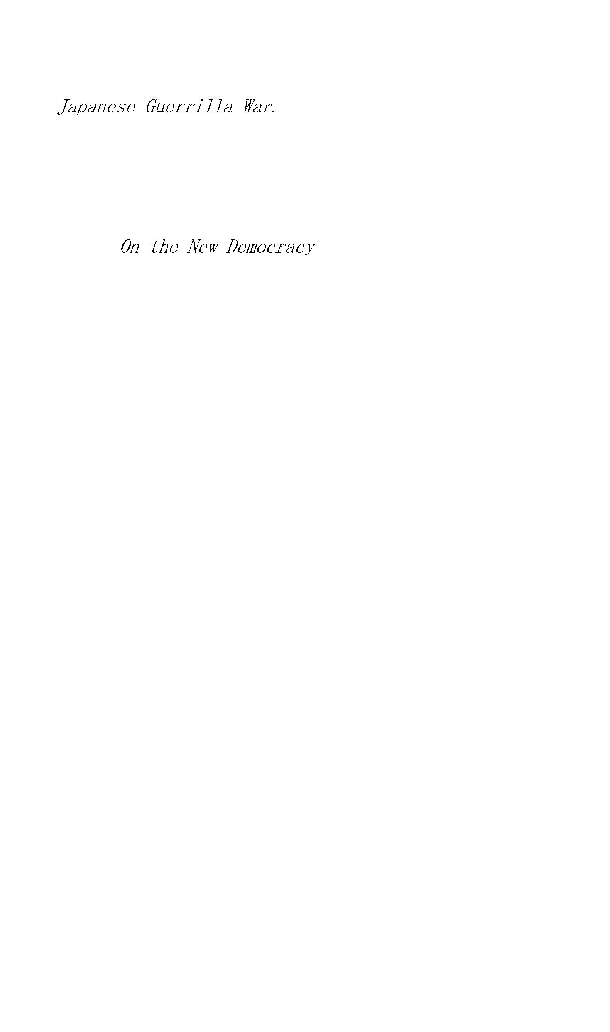

Germany defeated. Russia enters Far Eastern war; signs

alliance with Chiang Kai-shek’s government. Mao’s

report On

becomes formal basis of

Communist demands to end Kuomintang dictatorship. After

V-E Day, Communist-led forces flood North China and

Manchuria, competing with American-armed Nationalists.

U.S. Ambassador Hurley flies Mao Tse-tung to Chungking

to negotiate with Chiang Kai-shek. Yalta Pact promises

Taiwan to China. Death of Roosevelt. Truman uses atomic

bomb on Hiroshima. End of Second World War.

VI.

1946 Nationalists and Communists fail to agree on

“coalition government”; in June the Second Civil War,

called by the Communists the War of Liberation, begins.

Under Soviet Russian Occupation, Eastern Europe “goes

Red.”

1947 Mao’s

outlines

strategic and tactical plans, calling for general

offensive against Nationalists. Truman Doctrine

proclaimed in Greece.

1948 Despite U.S. aid to Nationalists, their defeat in

Manchuria is overwhelming. Yugoslavia is expelled from

Cominform, postwar successor to the Comintern.

1949 As his armies disintegrate, Chiang Kai-shek flees to

Taiwan. Over the rest of China the People’s Liberation

Army is victorious. In March, the Central Committee of

the CCP, led by Mao, arrives in Peking. Atlantic Pact

(NATO) proclaimed. U.S. “White Paper” blames

Chiang’s “reactionaries” for “loss of China.”

VII.

(1949–)

1949 Based on Mao’s

a People’s Political Consultative Conference is

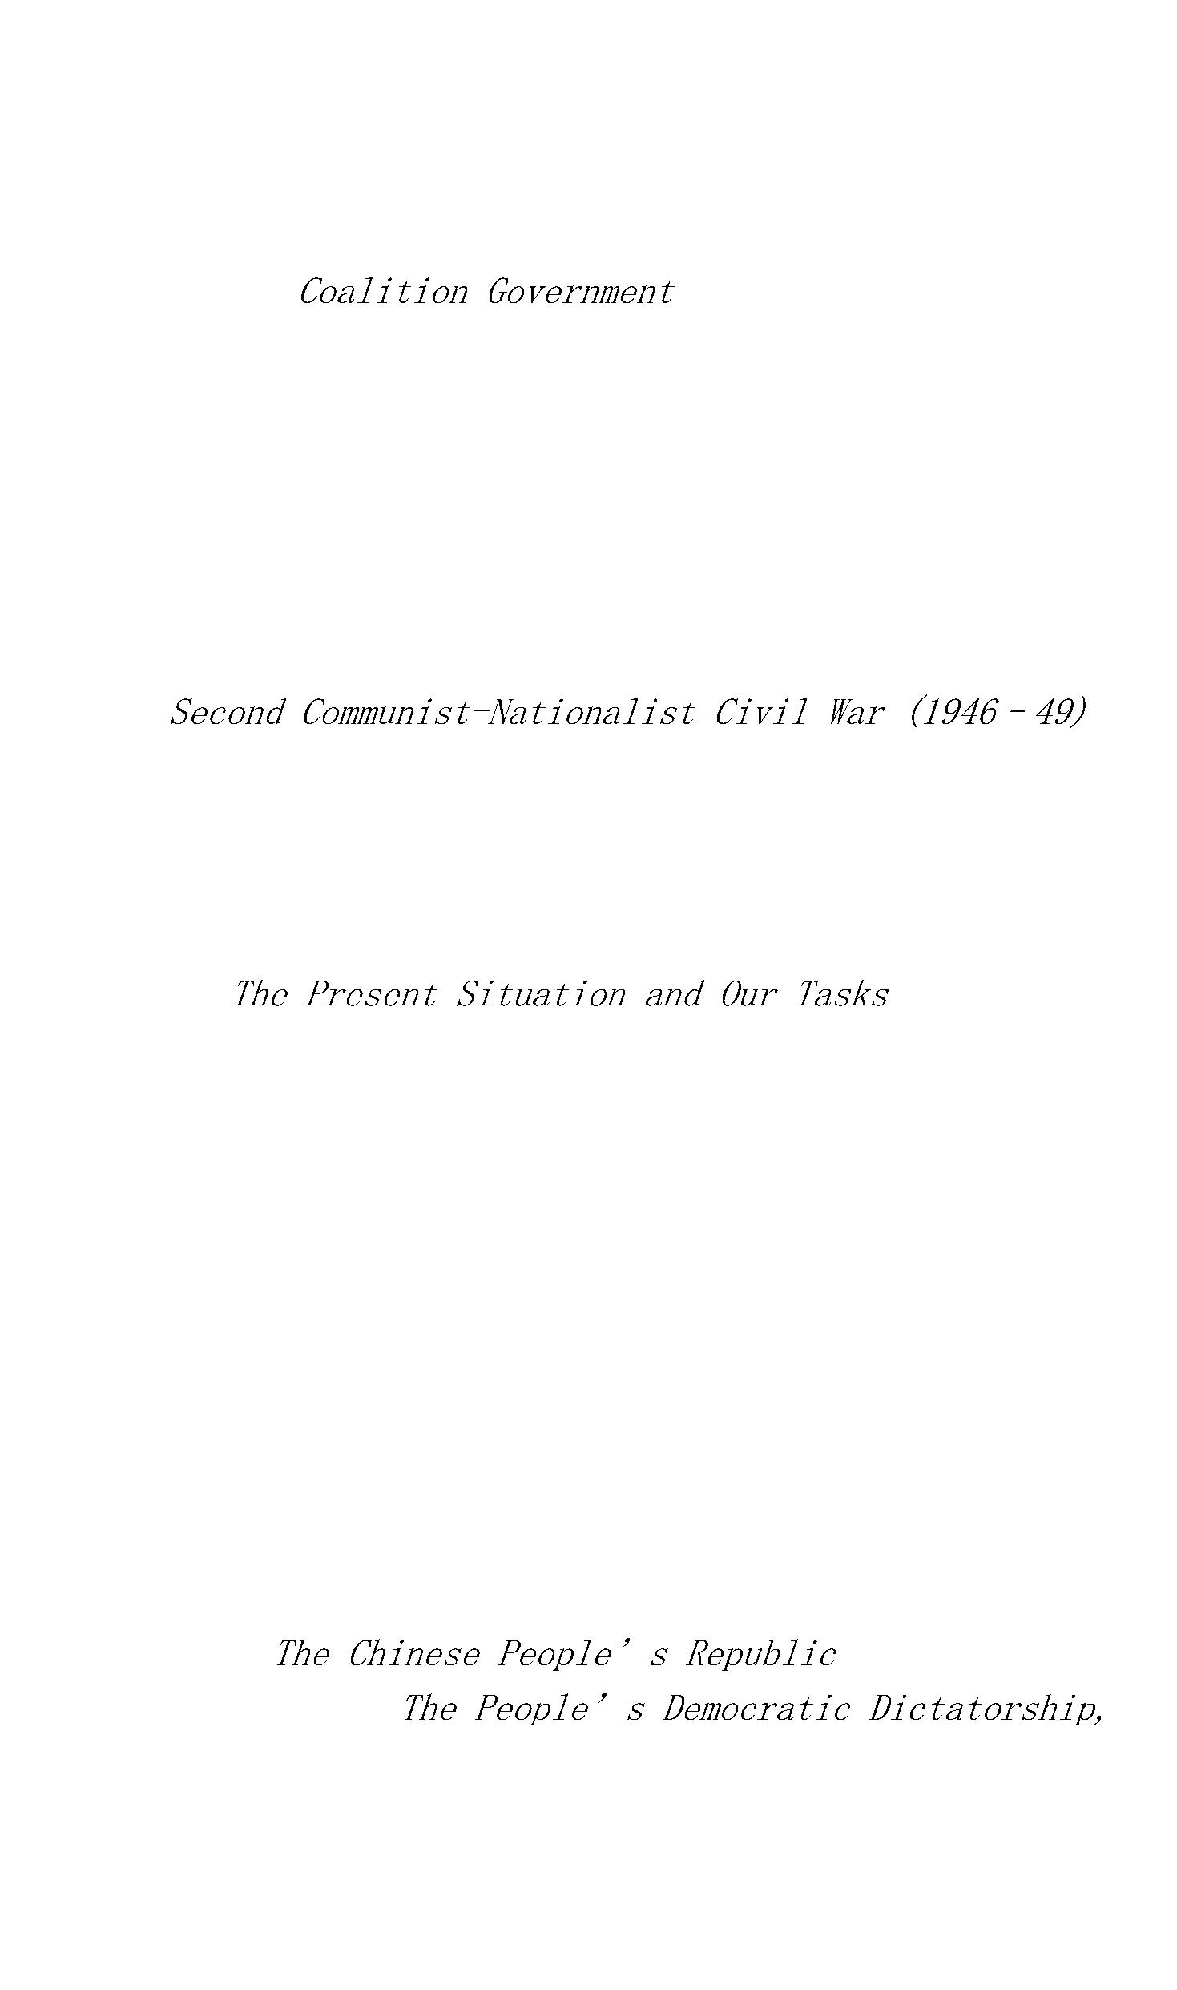

convened, in form representing workers, peasants,

intellectuals, national bourgeoisie. Chinese People’s

Government organized, with Mao elected chairman. On

October 1, Chinese People’s Republic formally

proclaimed in Peking. Mao announces foreign policy of

“leaning to one side” (toward U.S.S.R.). Great

Britain, Soviet Russia, Norway, The Netherlands,

Sweden, Finland, Switzerland recognize the new

government; the United States withdraws its diplomats

from China. Mao Tse-tung leaves for Moscow—his first

trip abroad. U.S. Communist Party leaders convicted of

advocating violent overthrow of the government.

1950 Mao concludes Sino-Soviet treaty of alliance; Stalin

grants China $300,000,000 loan. Korean War breaks out

(June) and Chinese “Volunteers” intervene (October).

India proclaims independence.

1951–52 With Soviet aid, Chinese resistance in Korea

continues. American forces, barred from carrying war

into China by U.N. and Allied policies, hold positions

at Thirty-eighth Parallel in Korea. First hydrogen bomb

exploded (1952) by U.S.A.

1953 Stalin dies. Korean armistice signed. U.S. forms

alliance with Chiang Kai-shek, making Taiwan U.S.

protectorate. Peking announces First Five-Year Plan.

Soviet grants support for 156 large-scale Chinese

projects. Moscow agrees to liquidate Soviet-Chinese

joint enterprises and withdraw all troops from China.

Rosenbergs executed in the U.S.

1954 Khrushchev first visits Peking. Land reform

(redistribution) completed. Agricultural cooperatives

lay basis for collectivization (1957). State

establishes partnerships with remaining private

enterprise, preliminary to complete nationalization

(1957). Geneva Accords end French power in Indochina

and recognize independence of Vietnam, Laos, and

Cambodia. Under the influence of Secretary of State



John Foster Dulles, the Eisenhower administration takes

“note” of Geneva Accords, but begins intervention in

support of Ngo Dinh Diem.

1955 At Bandung Conference (twenty-nine Afro-Asian nations)

China seeks broader anti-imperialist role against U.S.

and allies. China’s “foreign aid” program competes

with that of U.S.S.R. Warsaw Pact signed by U.S.S.R.

and East European satellites.

1956 Khrushchev denounces Stalin at Twentieth Congress of

CPSU. He proclaims end of personality cult and

beginning of collective leadership. “Hundred Flowers”

period invites criticism of CCP from dissatisfied

Chinese intellectuals. Hungarian revolt; Peking backs

suppression. China publishes important Maoist thesis,

acknowledging continued “contradictions”

within and between socialist states.

1957 Mao’s

defines limitations of criticism in relation

to the Party; advances thesis of “unity-criticism-

unity” as dialectical process to isolate “enemies of

socialism” and peacefully resolve “nonantagonistic”

conflicts of interest between the state, the Party, and

“the people.” Russia agrees to supply sample atom

bomb to China and help in nuclear weapons development.

Sputnik launched. At November conference in Moscow, Mao

discerns a “turning point”: the “East Wind is

prevailing over the West Wind.” He contends socialist

forces outbalance capitalist forces. Thesis disputed by

Russians. Breakup of Sino-Soviet unity begins.

1958 China announces Second Five-Year Plan. Year of the

“Great Leap Forward” and People’s Communes.

Peking’s threat to liberate Taiwan provokes Sino-

American crisis. Khrushchev withholds unconditional

nuclear support for China, and Peking declines to place

Chinese forces under Soviet military command. Sino-

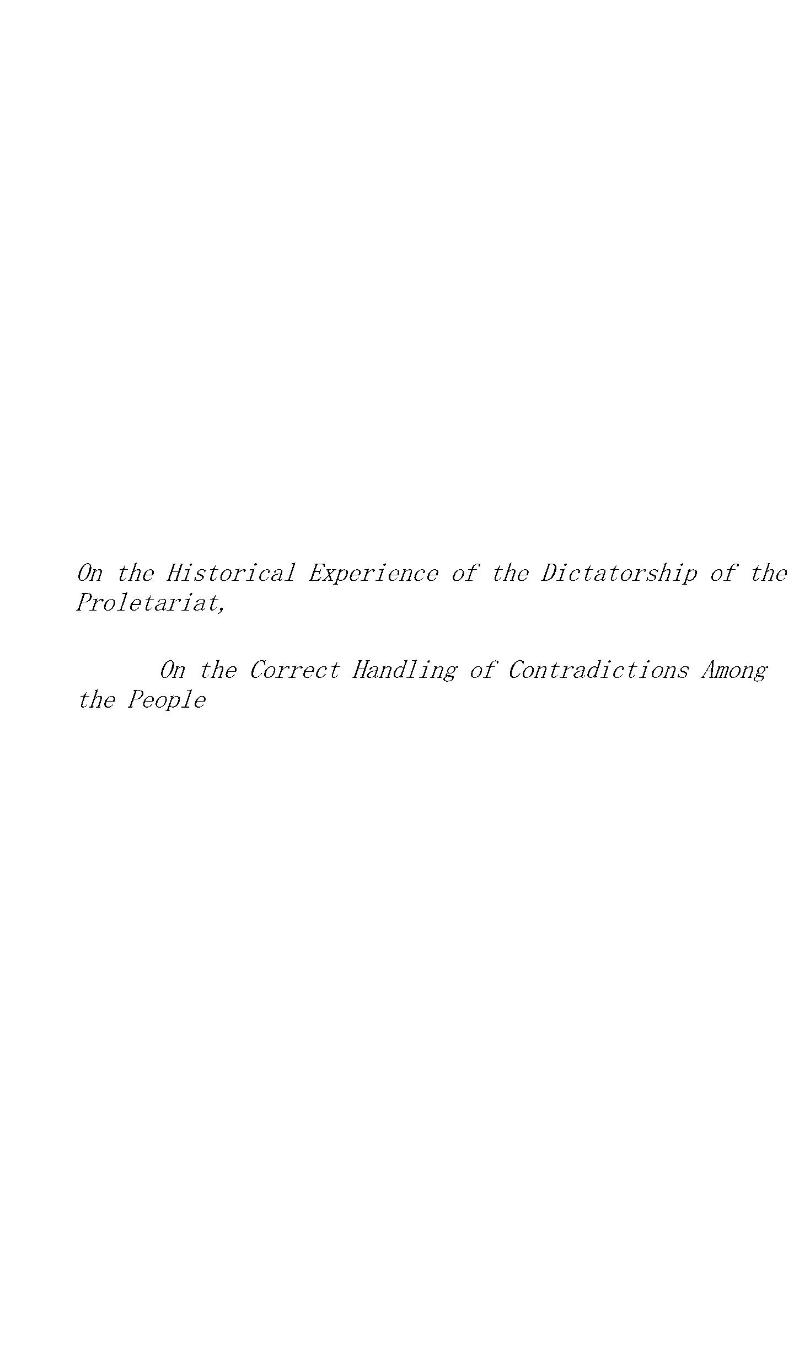

Soviet differences develop. First U.S. space satellite

launched.

1959 During October anniversary celebrations Khrushchev

again visits Peking, where he declares “imperialist

war is not inevitable.” His advocacy of “peaceful

coexistence” with “American imperialism” is sharply

rejected by Chinese. China gets no A-bomb and Mao loses

confidence in Khrushchev. Tibetan rebellion. Dalai Lama

flees to India. During China’s disputes with India and

Indonesia, Khrushchev offers aid to the latter. He

disparages Chinese people’s communes. Castro takes

power in Cuba. As U.S. increases armed intervention,

aimed to separate South Vietnam from the Republic,

President Ho Chi Minh backs People’s Liberation War in

the South.

1960 In July, Moscow recalls all Soviet advisers from China,

cancels more than 300 contracts, withdraws technical

help. At Moscow international Party conference

(November), Sino-Soviet “contradictions” intensify.

Chinese openly identify Khrushchev as “revisionist.”

Russians accuse Mao of seeking “world holocaust.”

Massive crop failure and industrial dislocation in

China. As Sino-Indian frontier incidents grow serious,

Khrushchev plays neutral role, continues economic aid

to India. John F. Kennedy elected U.S. President.

1961 At Twenty-second Soviet Party Congress in Moscow, Chou

En-lai walks out when Khrushchev bans Albanian Party.

Using texts from the newly published (1960)

Vol. IV, Peking’s Party press

proclaims Maoist and antirevisionist theses “true

Marxism-Leninism.” Chinese replace Soviet advisers in

Albania. Berlin Wall built.

1962 Sino-Soviet clashes on both state and Party levels

foreshadow wide international ideological fight.

Kennedy-Khrushchev duel over Cuba. When Khrushchev

withdraws missiles from Cuba, Peking ridicules him for

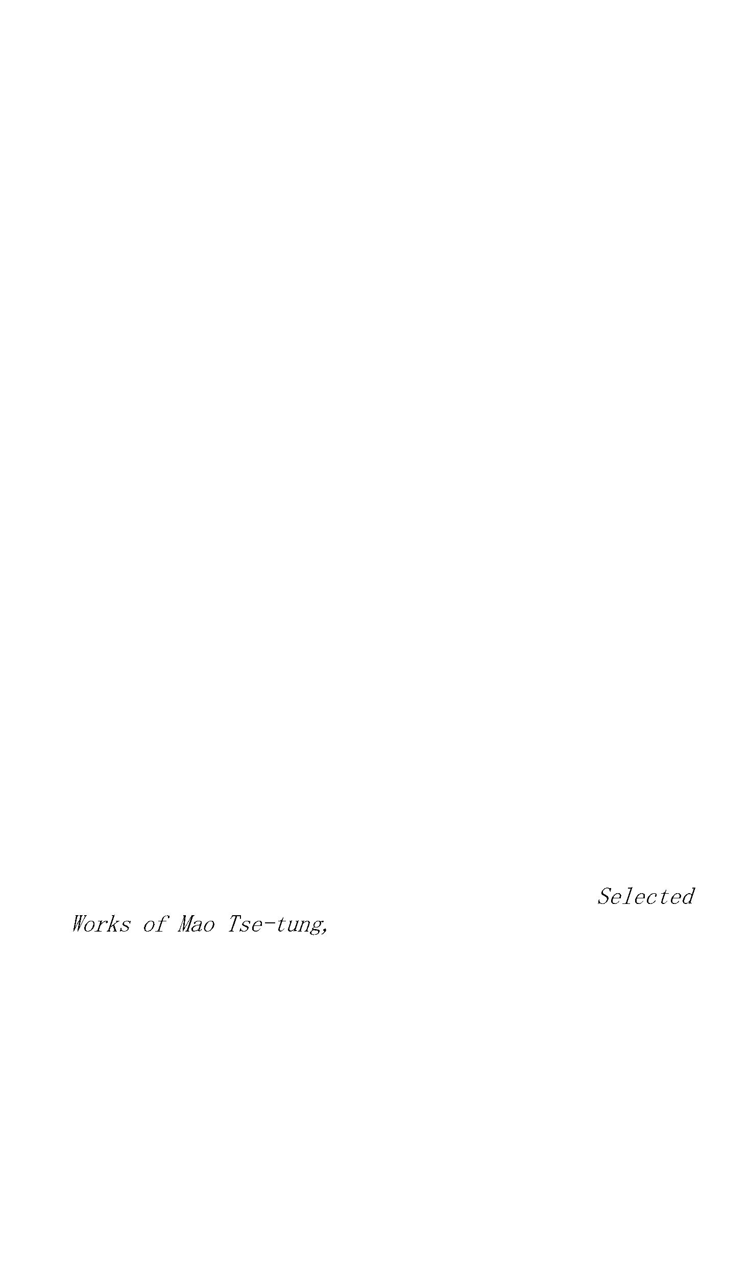

“adventurism” and “capitulationism.” Sino-Indian

border incidents climaxed by Chinese assault, driving

Indians from 35,000 square miles of territory. Chinese

troops withdraw, unilaterally create “demilitarized

zone,” call for peaceful negotiation. U.N. intervenes

in the Congo.

1960–63 Following the disruption of the Chinese economy

caused by dislocations during the “Great Leap

Forward,” by withdrawal of Soviet aid, and by a series

of natural calamities, the People’s Republic slowly

recovers from near-famine conditions.

1963 In final defiance of Peking’s demand for a militant

international “united front against American

imperialism,” Moscow signs nuclear test-ban treaty

with United States, makes “peaceful coexistence”

cardinal aim of Soviet foreign policy. Sino-Soviet

split now reflected in intraparty cleavages in many

countries. Mutual recriminations reinforced by open

publication of past charges and countercharges by CCP

and CPSU. Peking steps up drive for ideological

leadership among “third world” Asian-African-Latin

American revolutionary forces; Moscow strives to hold

following among European parties. Premier Chou En-lai

visits African countries. Mao Tse-tung issues

declaration calling upon “the people of the world” to

unite against American imperialism and support American

Negro struggles. President Kennedy assassinated.

1964 Breakdown in Soviet-Chinese party and state relations

becomes nearly complete. As France recognizes China,

Communist split paralleled by Western split. Chinese

offensive on two fronts—American imperialism and

Soviet revisionism—has some success in dividing both

camps. Two years of good harvests and new trade ties

with Europe and Japan strengthen Chinese economy.

Foreign Minister Ch’en Yi publicly expresses doubts

concerning value of Sino-Soviet military alliance;



China may no longer count on Russian aid. Mao urges

Japanese socialists to recover territories lost to

Russia and criticizes Soviet “imperialism” for

encroachments on Chinese territories.

After fifteen years, achievements of Chinese

revolution in uniting and modernizing China widely

conceded even by enemies. In rivalry with Russia, and

despite exclusion from United Nations, China becomes

major power with which—according to General de Gaulle

—United States must negotiate in order to end war in

Southeast Asia. Mao Tse-tung, following a century of

China’s humiliation as a weak and backward nation,

emerges as the first Asian political leader to attract

significant world following. China explodes its first

“nuclear device.”

South Vietnamese Government, backed by the United

States and badly defeated by growing forces of the

National Liberation Front, verges on disintegration

before proneutralist and propeace elements.

1965 President Johnson, soon after his January inauguration,

moves American combat troops into Vietnam to prevent a

neutralist coup in Saigon. In February he orders

massive bombing of North Vietnam. Peking announces its

readiness to intervene in support of the Democratic

Republic of Vietnam if President Ho Chi Minh demands

it, but in an interview with the author in January,

Chairman Mao declares that China will not go to war

against the United States unless China is directly

attacked. In July, Lin Piao, China’s Minister of

Defense, publishes a declaration, “Long Live the

Victory of the People’s War!” which calls upon the

underdeveloped nations, likened to the “rural areas of

the world,” to join forces against American and

Western imperialism, the “cities of the world.”

China explodes its second nuclear device.



The United Nations vote on the admission of the

People’s Republic ends in a 47–47 tie, with Great

Britain for the first time voting in favor of seating

Peking. Lacking majority support, the move is once more

defeated.

1966 U.S. forces in Vietnam approach 500,000 men, and

American bombing of North Vietnam spares few tagets

except inner metropolitan areas of Hanoi and Haiphong.

Russia sends North Vietnam aircraft, weapons, and

technical personnel; China supplies small arms and

food.

China launches a “Great Proletarian Cultural

Revolution” (GPCR) under Mao Tse-tung, with Lin Piao

named as his “close comrade-in-arms.” China prepares

for an expected American invasion. An unprecedented

purge attacks “bourgeois” and “revisionist”

elements in the CCP. Chinese agriculture continues to

improve, while scientific advances include the world’s

first synthesis of protein (insulin) and benzine.

1967 Great Proletarian Cultural Revolution develops into an

attack on Liu Shao-ch’i, chairman of government and

former first deputy Party leader, and on Teng Hsiao-

p’ing, general secretary of the Party, as foremost

among “those in the Party in authority who are taking

the capitalist road.” Profound intraparty struggle

intensifies.

As the GPCR took foreign political experts on China

by complete surprise, so China’s explosion of a

hydrogen bomb—twenty-six months after atomic fission

was achieved—nonpluses foreign military and scientific

savants. The same step had taken the U.S. more than

seven years; France, after eight years of effort, had

yet to test its first H-bomb.

Dean Rusk, U.S. Secretary of State, appeals for world

sympathy for Johnson’s armed intervention and massive

bombing in Vietnam as necessary in order to contain “a



billion Chinese armed with nuclear weapons,” but no

European power offers to help Rusk. China’s own

official policy still calls for an international

agreement to destroy all nuclear weapons—an invitation

ignored by the U.S. On December 19, in a message to

Vietnam’s National Liberation Front presidium, Mao

advises “the fraternal South Vietnamese people” to

“rest assured that your struggle is our struggle.”

China detonates its seventh nuclear device, in the

rapid development of a system of deterrents which could

enhance her immunity from nuclear attack if China

became directly engaged with U.S. ground forces in

eastern Asia.

1968 In January, during an intelligence-gathering tour off

the North Korean coast, the U.S. ship

is boarded

by North Korean sailors and surrenders. In the ensuing

crisis China calls for a united front among

revolutionary parties in Burma, Thailand, Laos,

Cambodia, and North Korea in support of the Vietnamese.

(North Korea has a military alliance with the U.S.S.R.

and the CPR.) The

incident makes it manifest

that durable peace between China and the U.S. remains

impossible while any part of Asia is subject to armed

American intervention.

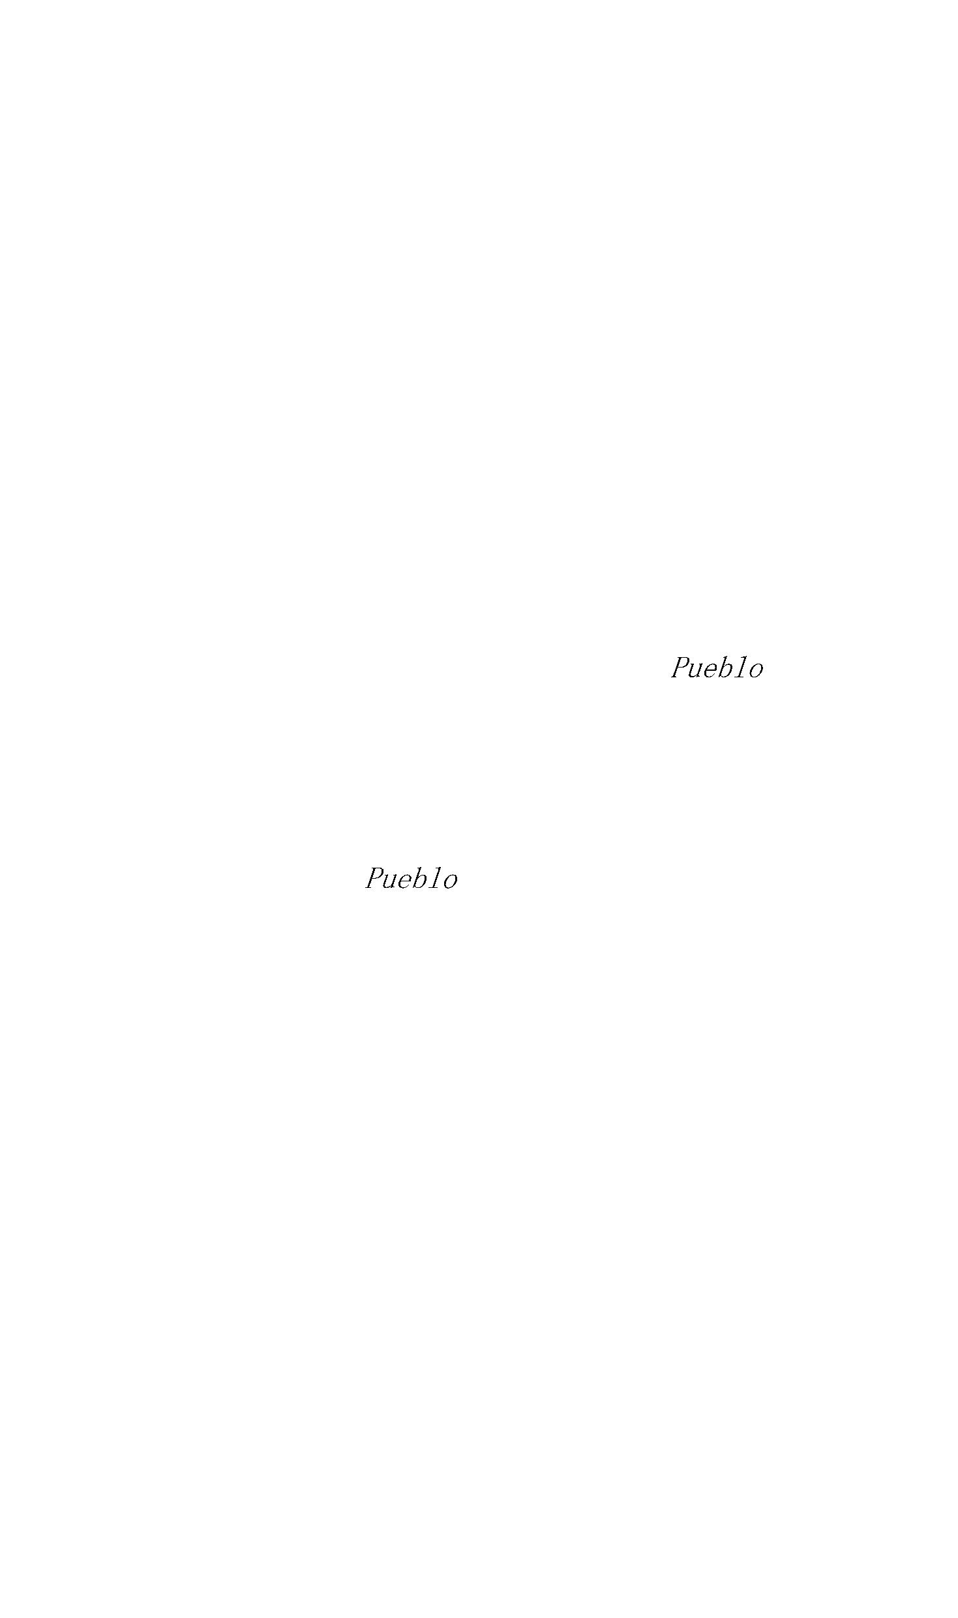

It is not necessary to strangle over the pronunciation of

Chinese names if one observes a few simple rules in the

rather arbitrary but workable Wade-Giles System of

transliteration (romanization) of the language into English.

Each Chinese character represents only one sound and

homonyms are innumerable. Chinese is monosyllabic, but

combinations of characters in the spoken language may form a

single idea or equivalent of one foreign word, and thus in a

sense the spoken language is polysyllabic. Chinese surnames

come first, given names (usually two words) follow, as in

Teng Hsiao-p’ing. Aspirates are represented in this book by

apostrophes; they indicate a soft consonantal sound.

Examples:

(as in Chi Chao-t’ing) is pronounced “Gee,” but

Ch’i (as in Liu Shao-ch’i) sounds like “Chee.”

is exactly our “chin.”

is like “Ju,” in Chu Teh, but Ch’u equals

“Chew.”

is “dzung”;

“Patsy.”

with the “ts” as in

is our word sound “die”;

“tie.”

is “buy” and p’ai is “Pie.”

Kung is like “Gung” (-a Din);

in “kind.”

with the “k” as

is the equivalent of “r” but roll it, as rrrun.

before an s, as in hsi, is the equivalent of an

aspirate but is often dropped, as in Sian for Hsian.

One may ignore the “h” and still be understood.

Single Chinese words are always pronounced as

monosyllables. Thus:

is not “Chee-yi-ang” but a

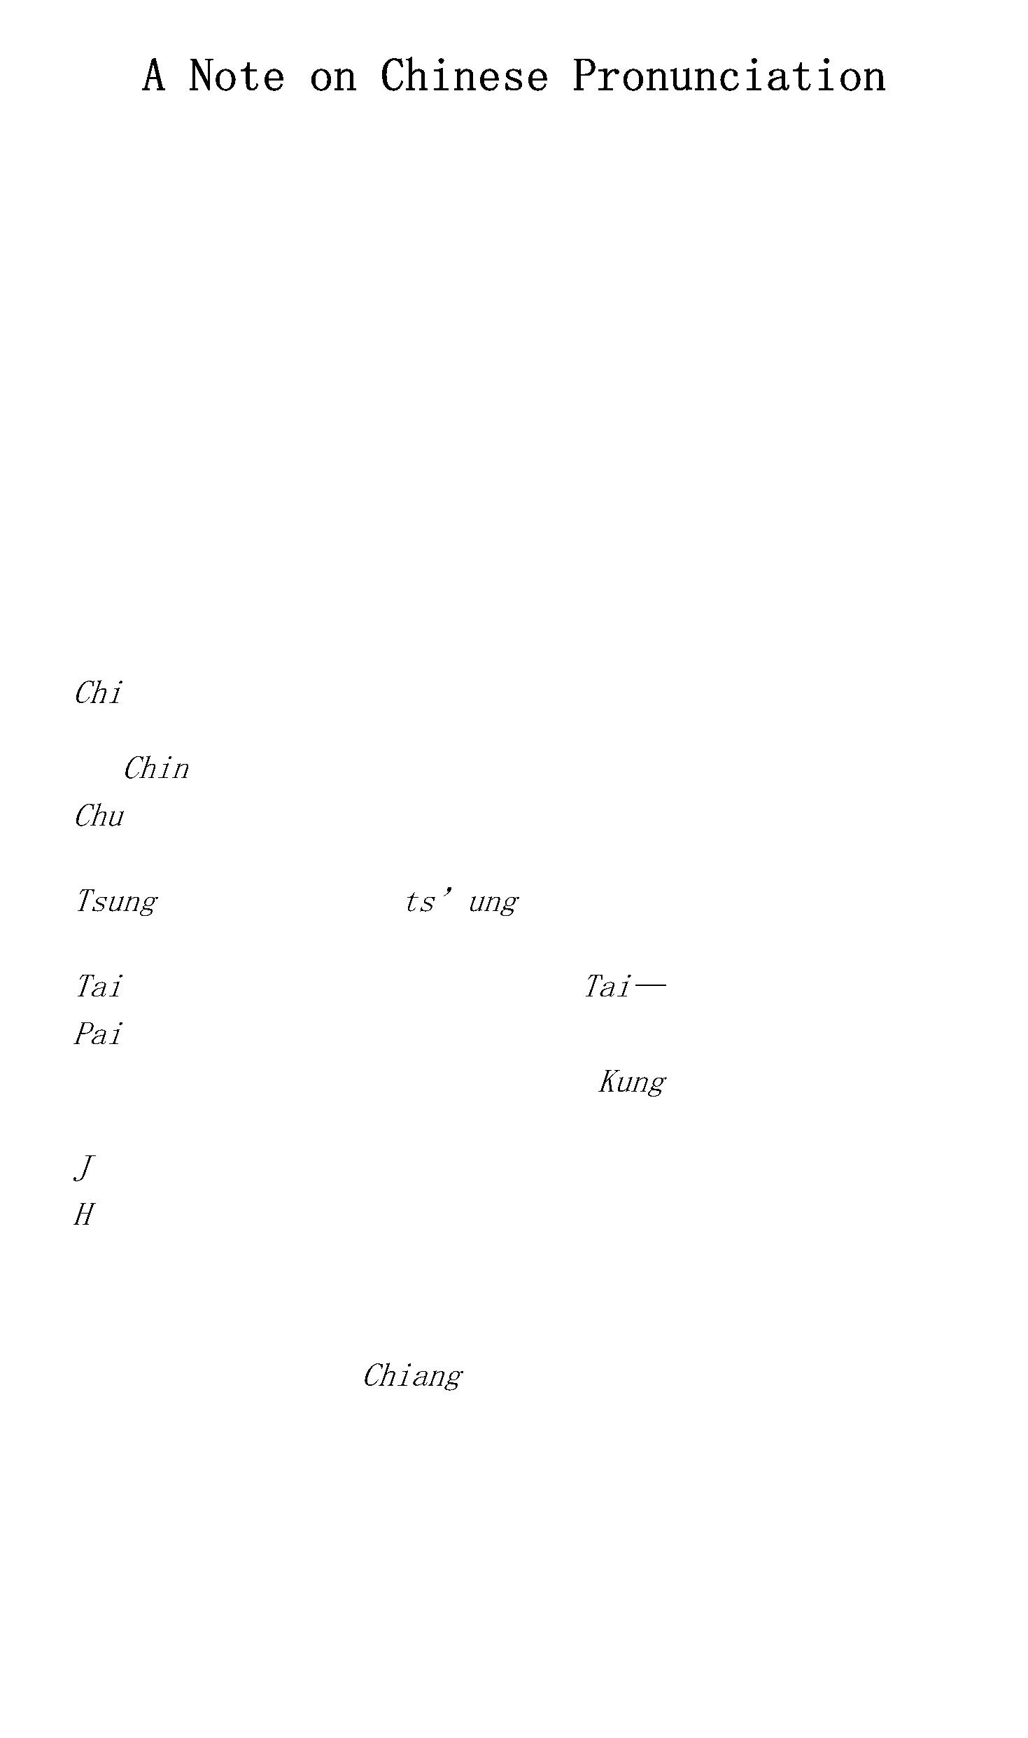

single sound, “Geeang.” is not “May-ow” but

pronounced like a cat’s “miaow” the “i.”

is “Joe Un-lie,” but the last syllable of his

wife’s given name, Ying-

sounds like “chow.”

Vowels in Chinese are generally short or medium, not long

and flat. Thus T’ang sounds like “dong,” never like our

“tang.”

as in

father

—run

is “tong.”

There is also a “ü” as in German and an

“ê” as in

—hen

French. I have omitted Wade’s umlaut and

circumflex

markings, which are found in European

latini-zations of Chinese.

—her

o—look

—go

—soon

These sounds indicate Chinese as spoken in

the

northern (Peking, mandarin) speech, which is now the

national language, taught in all schools. Where journalism

has already popularized misspellings or variants in other

dialects, such as Chiang Kai-shek for Chiang Chieh-shih,

etc., I have followed the familiar version.

Chinese words frequently encountered in place names are:

—province;

(or king)—capital;

county;

—city;

—township;

—village;

(kiang)—great river; —river; —lake;

mouth; —north; —south; —east; (or si)—

west; —central; —mountain. Such words combine

in the following examples: (properly, Pei-ching,

—

pronounced “Bay-ging”), meaning “northern capital.”

Peking was renamed “Pei-p’ing (Peiping or, erroneously,

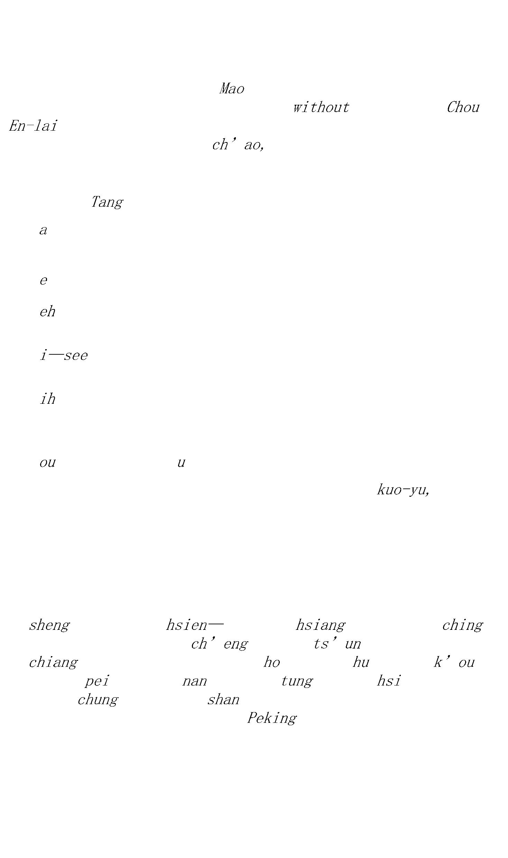

Peping), “northern peace” (or tranquillity), by the

Kuomintang regime, which made its seat in Nanking

(southern capital), but the historic name remained in

general use and was formally restored in 1949.

means East of the mountains.

West of the mountains.

—Mouth of the Han (river).

—Western Peace (tranquillity).

—North of the (Yellow) river.

—South of the lakes.

—South of the clouds.

—West of the river.

There is also a “ü” as in German and an “é” as in

French. I have omitted Wade’s umlaut and circumflex

markings, which are found in European latini-zations of

Chinese.

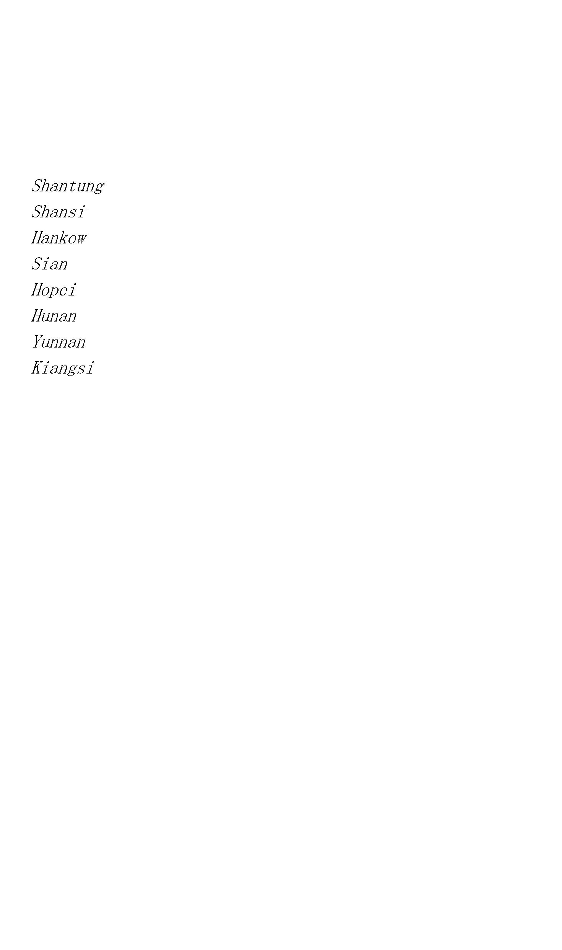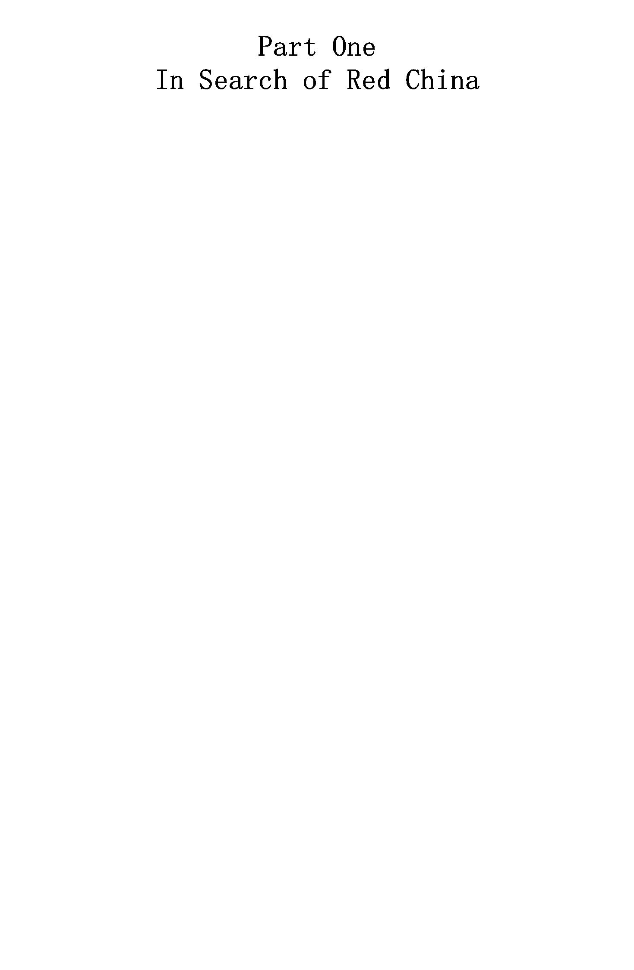

During my seven years in China, hundreds of questions had

been asked about the Chinese Red Army, the Soviets, and the

Communist movement. Eager partisans could supply you with a

stock of ready answers, but these remained highly

unsatisfactory. How did they

Red China.

They had never been to

The fact was that there had been perhaps no greater

mystery among nations, no more confused an epic, than the

story of Red China. Fighting in the very heart of the most

populous nation on earth, the Celestial Reds had for nine

years been isolated by a news blockade as effective as a

stone fortress. A wall of thousands of enemy troops

constantly surrounded them; their territory was more

inaccessible than Tibet. No one had voluntarily penetrated

that wall and returned to write of his experiences since the

first Chinese soviet was established in southeastern Hunan,

in November, 1927.

Even the simplest points were disputed. Some people denied

that there was such a thing as a Red Army. There were only

thousands of hungry brigands. Some denied even the existence

of soviets. They were an invention of Communist propaganda.

Yet Red sympathizers extolled both as the only salvation for

all the ills of China. In the midst of this propaganda and

counterpropaganda, credible evidence was lacking for

dispassionate observers seeking the truth. Here are some of

the unanswered questions that interested everyone concerned

with politics and the quickening history of the Orient:

Was or was not this Red Army of China a mass of conscious

Marxist revolutionaries, disciplined by and adhering to a

centralized program and a unified command under the Chinese

Communist Party? If so, what was that program? The

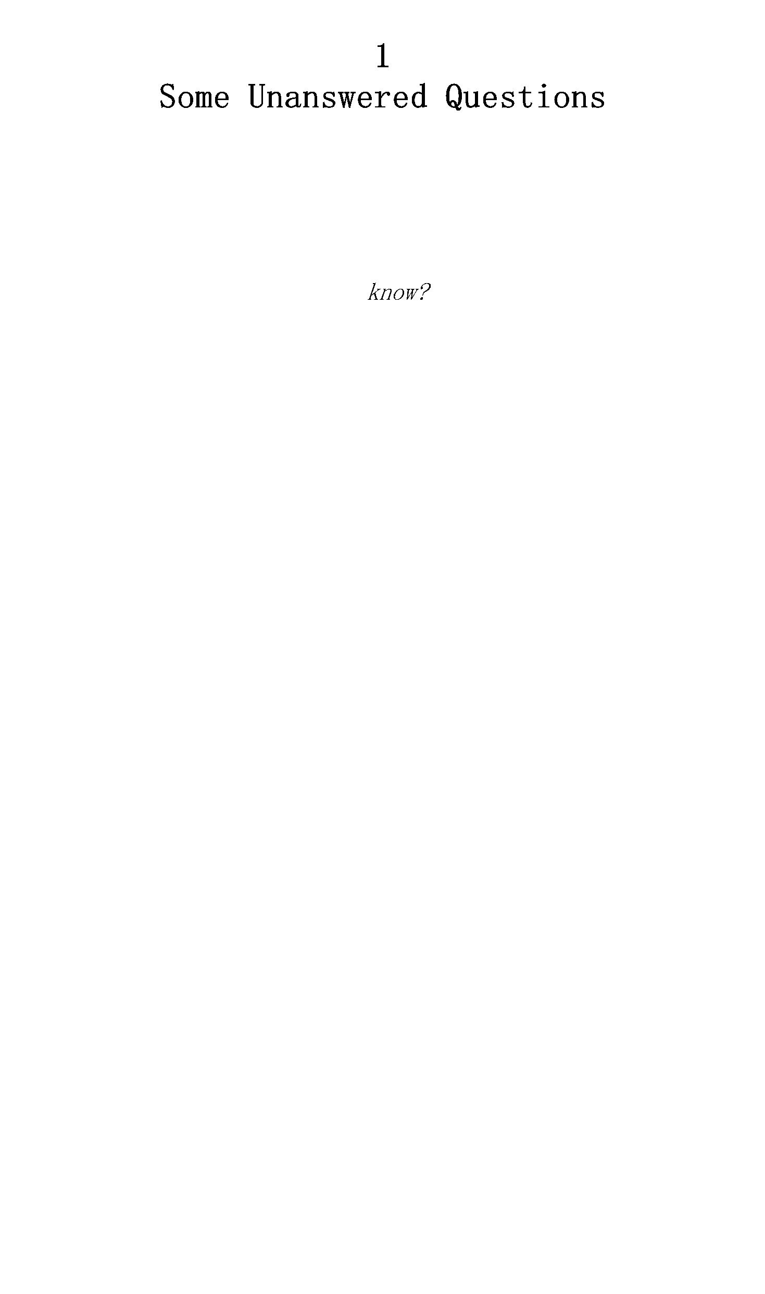

Communists claimed to be fighting for agrarian revolution,

and against imperialism, and for soviet democracy and

national emancipation. Nanking said that the Reds were only

a new type of vandals and marauders led by “intellectual

bandits.” Who was right? Or was either one?

Before 1927, members of the Communist Party were admitted

to the Kuomintang, but in April of that year there began a

great “purgation.” Communists, as well as unorganized

radical intellectuals and thousands of organized workers and

peasants, were executed on an extensive scale under Chiang

Kai-shek, the leader of a Right

which seized

power, to form a “National Government” at Nanking. Since

then it had been a crime punishable by death to be a

Communist or a Communist sympathizer, and thousands had paid

that penalty. Yet thousands more continued to run the risk.

Thousands of peasants, workers, students, and soldiers

joined the Red Army in armed struggle against the military

dictatorship of the Nanking regime. Why? What inexorable

force drove them on to support suicidal political opinions?

What were the fundamental quarrels between the Kuomintang

and the Kungch’antang?*

What were the Chinese Communists like? In what way did

they resemble, in what way were they unlike, Communists or

Socialists elsewhere? The tourist asked if they wore long

beards, made noises with their soup, and carried homemade

bombs in their briefcases. The serious-minded wanted to know

whether they were “genuine” Marxists. Did they read

and the works of Lenin? Had they a thoroughly

Socialist economic program? Were they Stalinites or

Trotskyites? Or neither? Was their movement really an

organic part of the World Revolution? Were they true

internationalists? “Mere tools of Moscow,” or primarily

nationalists struggling for an independent China?

Who were these warriors who had fought so long, so

fiercely, so courageously, and—as admitted by observers of

every color, and privately among Generalissimo Chiang Kai-

shek’s own followers—on the whole so invincibly? What made

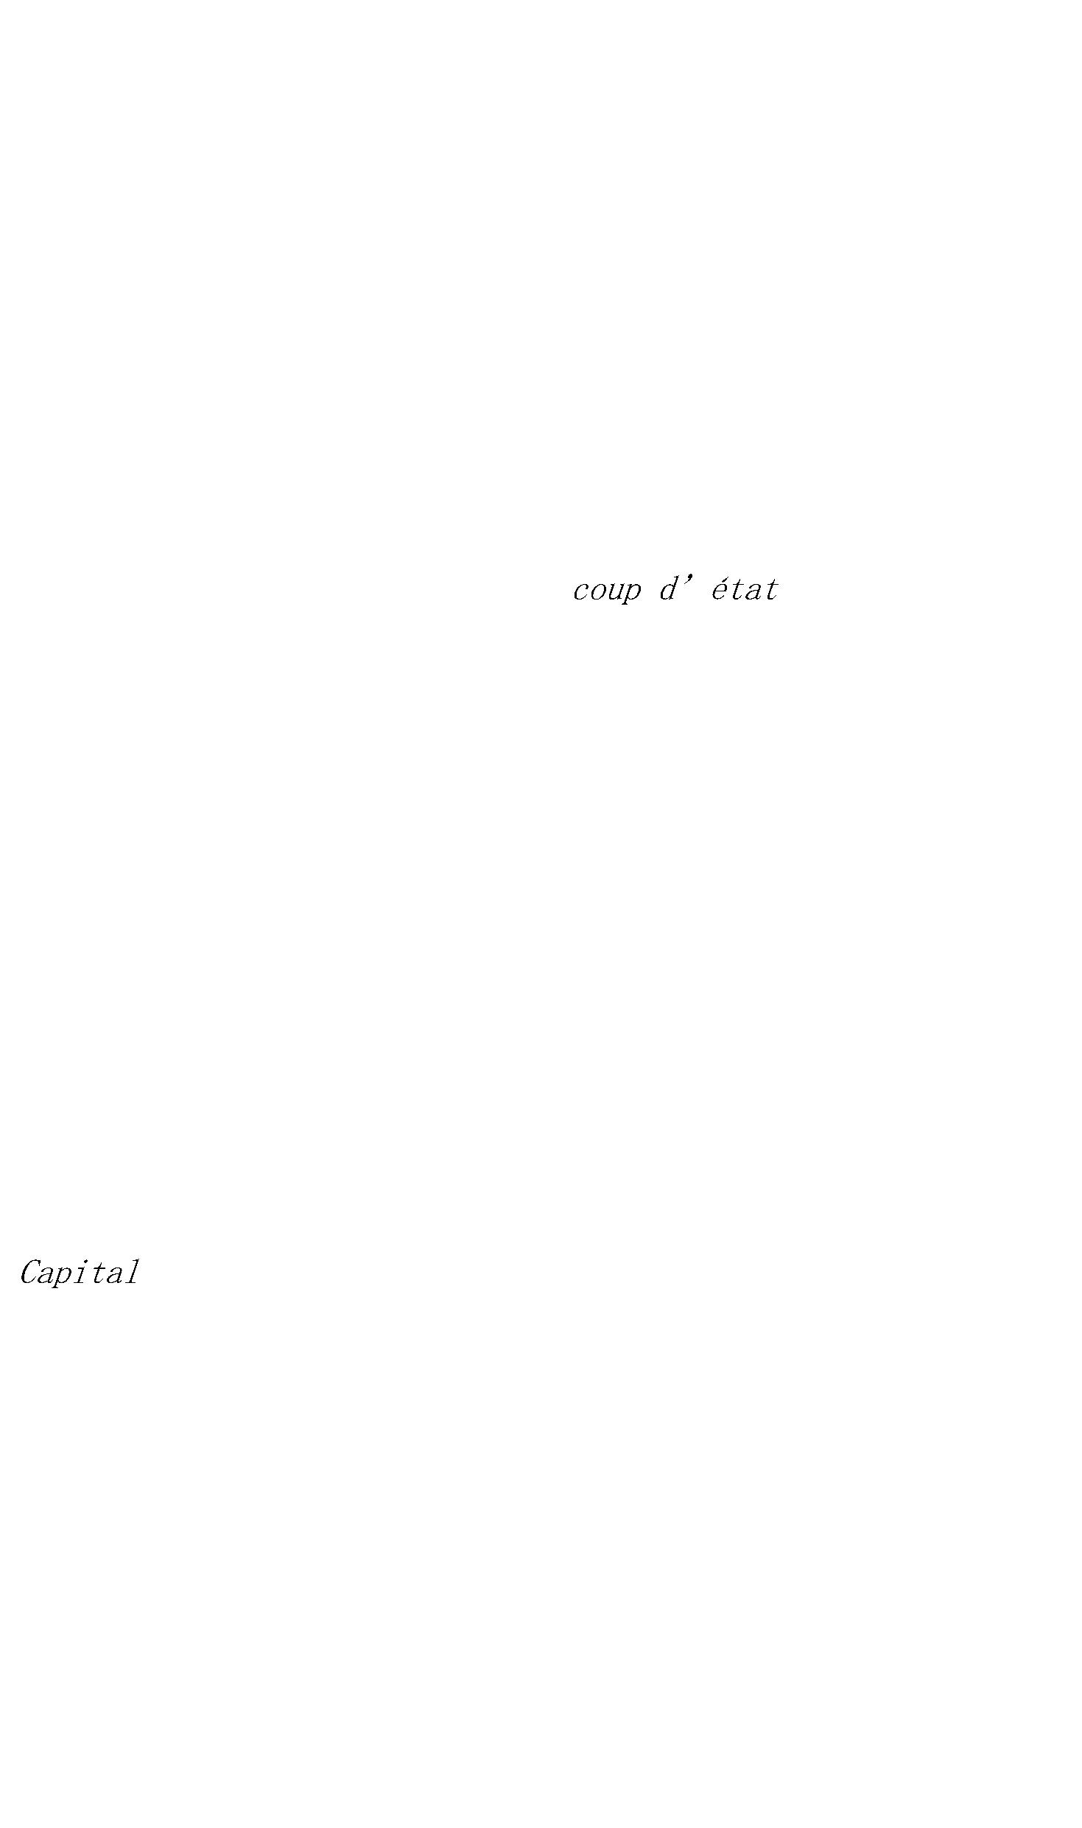

them fight like that? What held them up? What was the

revolutionary basis of their movement? What were the hopes

and aims and dreams that had made of them the incredibly

stubborn warriors—incredible compared with the history of

compromise that is China—who had endured hundreds of

battles, blockade, salt shortage, famine, disease, epidemic,

and finally the Long March of 6,000 miles, in which they

crossed twelve provinces of China, broke through thousands

of Kuomintang troops, and triumphantly emerged at last into

a new base in the Northwest?

Who were their leaders? Were they educated men with a

fervent belief in an ideal, an ideology, and a doctrine?

Social prophets, or mere ignorant peasants blindly fighting

for an existence? What kind of man was Mao Tse-tung,* No. 1

“Red bandit” on Nanking’s list, for whose capture, dead

or alive, Chiang Kai-shek offered a reward of a quarter of a

million silver dollars?† What went on inside that highly

priced Oriental head? Or was Mao really already dead, as

Nanking officially announced? What was Chu Teh‡ like—the

commander-in-chief of the Red Army, who life had the same

value to Nanking? What about Lin Piao,‡ the twenty-eight-

year-old Red tactician whose famous First Red Army Corps was

said never to have suffered a defeat? Where did he come

from? Who were the many other Red leaders repeatedly

reported dead, only to reappear in the news—unscathed and

commanding new forces against the Kuomintang?

What explained the Red Army’s remarkable record of

resistance for nine years against vastly superior military

combinations? Lacking any industrial base, big cannon, gas,

airplanes, money, and the modern techniques which Nanking

had utilized in its wars against them, how had these Reds

survived, and increased their following? What military

tactics did they use? How were they instructed? Who advised

them? Were there some Russian military geniuses among them?

Who led the outmaneuver-ing, not only of all Kuomintang

commanders sent against them but also of Chiang Kai-shek’s



large and expensive staff of German advisers, headed first

by General von Seeckt and later by General von Falkenhausen?

What was a Chinese soviet like? Did the peasants support

it? If not, what held it together? To what degree did the

Reds carry out “socialism” in districts where they had

consolidated their power? Why hadn’t the Red Army taken big

cities? Did this prove that it wasn’t a genuine

proletarian-led movement, but fundamentally remained a

peasant rebellion? How was it possible to speak of

“communism” or “socialism” in China, where over 80 per

cent of the population was still agrarian, where

industrialism was still in infant garments—if not infantile

paralysis?

How did the Reds dress? Eat? Play? Love? Work? What were

their marriage laws? Were women “nationalized,” as

Kuomintang publicists asserted? What was a Chinese “Red

factory”? A Red dramatic society? How did they organize

their economy? What about public health, recreation,

education, “Red culture”?

What was the strength of the Red Army? Half a million, as

the Comintern publications boasted? If so, why had it not

seized power? Where did it get arms and munitions? Was it a

disciplined army? What about its morale? Was it true that

officers and men lived alike? If, as Generalissimo Chiang

announced in 1935, Nanking had “destroyed the menace of

Communist banditry,” what explained the fact that in 1937

the Reds occupied a bigger single unified territory (in

China’s most strategic Northwest) than ever before? If the

Reds were finished, why did Japan demand, as the famous

Third Point of Koki Hirota (Foreign Minister, 1933–36),

that Nanking form an anti-Red pact with Tokyo and Nazi

Germany “to prevent the bolshevization of Asia”? Were the

Reds really “anti-imperialist”? Did they want war with

Japan? Would Moscow support them in such a war? Or were

their fierce anti-Japanese slogans only a trick and a

desperate attempt to win public sympathy, the last cry of



demoralized traitors and bandits, as the eminent Dr. Hu Shih

nervously assured his excited students in Peking?

What were the military and political perspectives of the

Chinese Communist movement? What was the history of its

development? Could it succeed? And just what would such

success mean to us? To Japan? What would be the effect of

this tremendous mutation upon a fifth (some said a fourth)

of the world’s inhabitants? What changes would it produce

in world politics? In world history? How would it affect the

vast British, American, and other foreign investment in

China? Indeed, had the Reds any “foreign policy” at all?

Finally, what was the meaning of the Communists’ offer to

form a “national united front” in China, and stop civil

war?

For some time it had seemed ridiculous that not a single

non-Communist observer could answer those questions with

confidence, accuracy, or facts based on personal

investigation. Here was a story, growing in interest and

importance every day; here was story of China, as

newspaper correspondents admitted to each other between

dispatches sent out on trivial side issues. Yet we were all

woefully ignorant about it. To get in touch with Communists

in the “White” areas was extremely difficult.

Communists, over whose heads hung the sentence of death,

did not identify themselves as such in polite—or impolite—

society. Even in the foreign concessions, Nanking kept a

well-paid espionage system at work. It included, for

example, such vigilantes as C. Patrick Givens, former chief

Red-chaser in the British police force of Shanghai’s

International Settlement. Inspector Givens was each year

credited with the arrest—and subsequent imprisonment or

execution, after extradition from the Settlement by the

Kuomintang authorities—of scores of alleged Communists, the

majority of them between the ages of fifteen and twenty-

five. He was only one of many foreign sleuths hired to spy

upon young Chinese radicals and hunt them down in their own

country.



We all knew that the only way to leam anything about Red

China was to go there. We excused ourselves by saying,

—“It can’t be done.” A few had tried and

failed. It was believed impossible. People thought that

nobody could enter Red territory and come out alive.

Then, in June, 1936, a close Chinese friend of mine

brought me news of an amazing political situation in

Northwest China—a situation which was later to culminate in

the sensational arrest of Generalissimo Chiang Kai-shek, and

to change the current of Chinese history. More important to

me then, however, I learned with this news of a possible

method of entry to Red territory. It necessitated leaving at

once. The opportunity was unique and not to be missed. I

decided to take it and attempt to break a news blockade nine

years old.

It is true there were risks involved, though the reports

later published of my death—“killed by bandits”—were

exaggerated. But against a torrent of horror stories about

Red atrocities that had for many years filled the subsidized

vernacular and foreign press of China, I had little to cheer

me on my way. Nothing, in truth, but a letter of

introduction to Mao Tse-tung, chairman of the Soviet

Government.1 All I had to do was to find him. Through what

adventures? I did not know. But thousands of lives had been

sacrificed in these years of Kuomintang-Communist warfare.

Could one foreign neck be better hazarded than in an effort

to discover why? I found myself somewhat attached to the

neck in question, but I concluded that the price was not too

high to pay.

In this melodramatic mood I set out.



It was early June and Peking wore the green lace of spring,

its thousands of willows and imperial cypresses making the

Forbidden City a place of wonder and enchantment, and in

many cool gardens it was impossible to believe in the China

of breaking toil, starvation, revolution, and foreign

invasion that lay beyond the glittering roofs of the

palaces. Here well-fed foreigners could live in their own

little never-never land of whisky-and-soda, polo, tennis,

and gossip, happily quite unaware of the pulse of humanity

outside the great city’s silent, insulating walls—as

indeed many did.

And yet during the past year even the oasis of Peking had

been invaded by the atmosphere of struggle that hovered over

all China. Threats of Japanese conquest had provoked great

demonstrations of the people, especially among the enraged

youth. A few months earlier I had stood under the bullet-

pitted Tartar Wall and seen ten thousand students gather,

defiant of the gendarmes’ clubbings, to shout in a mighty

chorus: “Resist Japan! Reject the demands of Japanese

imperialism for the separation of North China from the

South!”

All Peking’s defensive masonry could not prevent

reverberations of the Chinese Red Army’s sensational

attempt to march through Shansi to the Great Wall—

ostensibly to begin a war against Japan for recovery of the

lost territories. This somewhat quixotic expedition had been

promptly blocked by eleven divisions of Generalissimo Chiang

Kai-shek’s crack new army, but that had not prevented

patriotic students from courting imprisonment and possible

death by massing in the streets and uttering the forbidden

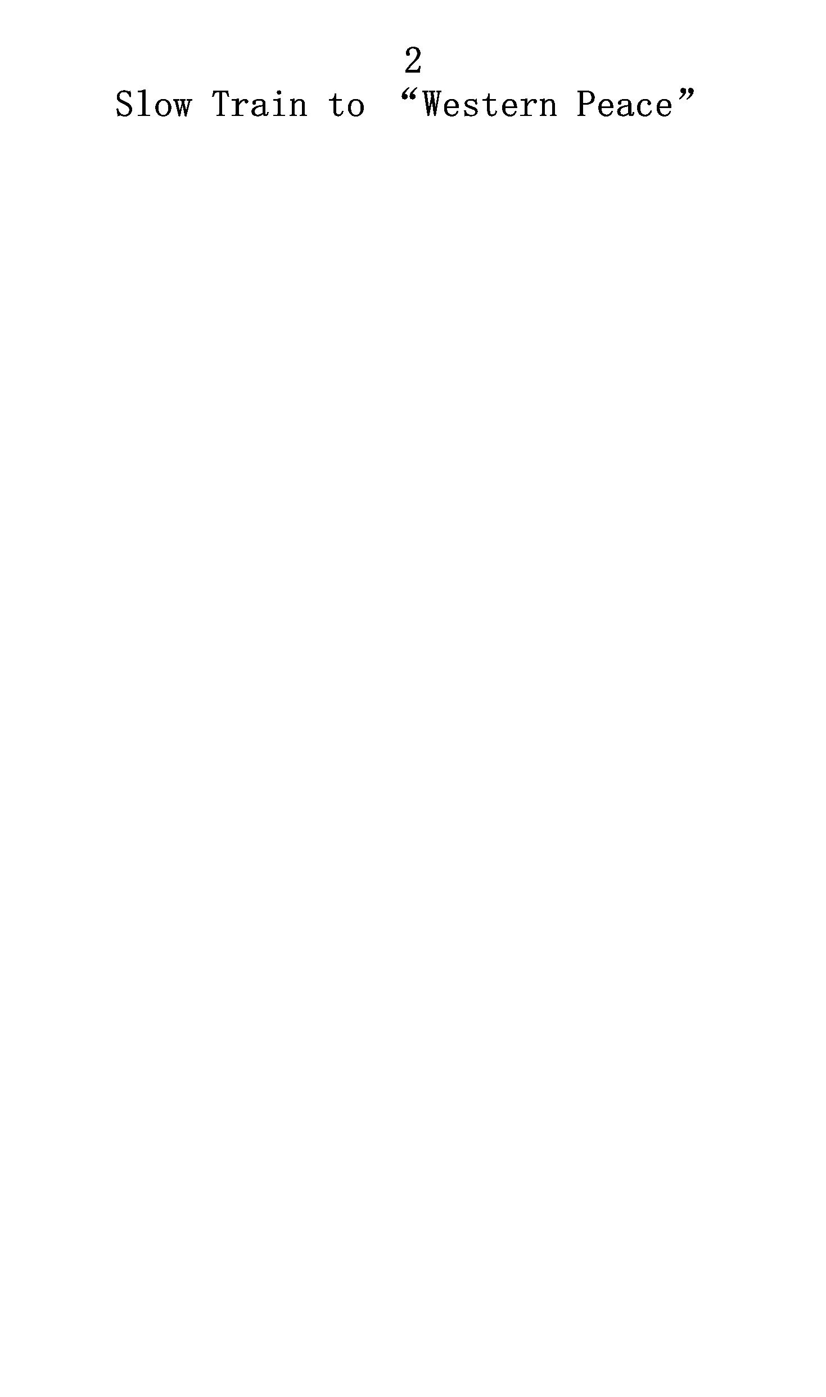

slogans: “Cease civil war! Cooperate with the Communists to

resist Japan! Save China!”*

One midnight I climbed aboard a dilapidated train, feeling

a little ill, but in a state of high excitement. Excitement

because before me lay a journey of exploration into a land

hundreds of years and hundreds of miles removed from the

medieval splendors of the Forbidden City: I was bound for

“Red China.” And a little ill because I had taken all the

inoculations available. A microbe’s-eye view of my

bloodstream would have revealed a macabre cavalcade; my arms

and legs were shot with smallpox, typhoid, cholera, typhus,

and plague germs. All five diseases were prevalent in the

Northwest. Moreover, alarming reports had lately told of the

spread of bubonic plague in Shensi province, one of the few

spots on earth where it was endemic.

My immediate destination was Sianfu—which means “Western

Peace.” Sianfu was the capital of Shensi province, it was

two tiresome days and nights by train to the southwest of

Peking, and it was the western terminus of the Lunghai

railway. From there I planned to go northward and enter the

soviet districts, which occupied the very heart of Ta Hsi-

pei, China’s Great Northwest. Lochuan, a town about one

hundred fifty miles north of Sianfu, then marked the

beginning of Red territory in Shensi. Everything north of

it, except strips of territory along the main highways, and

some points which will be noted later, was already dyed Red.

With Lochuan roughly the southern, and the Great Wall the

northern, extremities of Red control in Shensi, both the

eastern and western Red frontiers were formed by the Yellow

River. Coming down from the fringes of Tibet, the wide,

muddy stream flows northward through Kansu and Ninghsia, and

above the Great Wall into the province of Suiyuan—Inner

Mongolia. Then after many miles of uncertain wandering

toward the east it turns southward again, to pierce the

Great Wall and form the boundary between the provinces of

Shensi and Shansi.



It was within this great bend of China’s most treacherous

river that the soviets then operated—in northern Shensi,

northeastern Kansu, and southeastern Ninghsia. And by a

strange sequence of history this region almost corresponded

to the original confines of the birthplace of China. Near

here the Chinese first formed and unified themselves as a

people, thousands of years ago.

In the morning I inspected my traveling companions and

found a youth and a handsome old man with a wisp of gray

beard sitting opposite me, sipping bitter tea. Presently the

youth spoke to me, in formalities at first, and then

inevitably of politics. I discovered that his wife’s uncle

was a railway official and that he was traveling with a

pass. He was on his way back to Szechuan, his native

province, which he had left seven years before. But he was

not sure that he would be able to visit his home town after

all. Bandits were reported to be operating near there.

“You mean Reds?”

“Oh, no, not Reds, although there are Reds in Szechuan,

too. No, I mean bandits.”

“But aren’t the Reds also bandits?” I asked out of

curiosity. “The newspapers always call them Red bandits or

Communist bandits.”

“Ah, but you must know that the editors must call them

bandits because they are ordered to do so by Nanking,” he

explained. “If they called them Communists or

revolutionaries that would prove they were Communists

themselves.”

“But in Szechuan don’t people fear the Reds as much as

the bandits?”

“Well, that depends. The rich men fear them, and the

landlords, and the officials and tax collectors, yes. But

the peasants do not fear them. Sometimes they welcome

them.” Then he glanced apprehensively at the old man, who

sat listening intently, and yet seeming not to listen. “You

see,” he continued, “the peasants are too ignorant to



understand that the Reds only want to use them. They think

the Reds really mean what they say.”

“But they don’t mean it?”

“My father wrote to me that they did abolish usury and

opium in the Sungpan [Szechuan], and that they redistributed

the land there. So you see they are not exactly bandits.

They have principles, all right. But they are wicked men.

They kill too many people.”

Then surprisingly the graybeard lifted his gentle face and

with perfect composure made an astonishing remark.

he said. “They don’t kill enough!” We both looked

at him flabbergasted.

Unfortunately the train was nearing Chengchow, where I had

to transfer to the Lunghai line, and I was obliged to break

off the discussion. But I have ever since wondered with what

deadly evidence this Confucian-looking old gentleman would

have supported his startling contention. I wondered about it

all the next day of travel, as we climbed slowly through the

weird levels of loess hills in Honan and Shensi, and until

my train—this one still new and very comfortable—rolled up

to the new and handsome railway station at Sianfu.

Soon after my arrival I went to call on General Yang Hu-

ch’eng,* Pacification Commissioner of Shensi province.

Until a couple of years before, General Yang had been

undisputed monarch of those parts of Shensi not controlled

by the Reds. A former bandit, he rose to authority via the

route that had put many of China’s ablest leaders in

office, and on the same highway he was said to have

accumulated the customary fortune. But recently he had been

obliged to divide his power with several other gentlemen in

the Northwest. For in 1935 the “Young Marshal,” Chang

Hsueh-liang,* who used to be ruler of Manchuria, had brought

his Tungpei (Manchurian) army into Shensi, and assumed

office in Sianfu as supreme Red chaser in these parts—Vice-

Commander of the National Bandit-Suppression Commission. And

to watch the Young Marshal had come Shao Li-tzu,* an acolyte

